# PlaqueQuant –Blood Vessel Stenosis Quantification Software User Manual for Version3.0 FOR BETA VERSION ONLY

**Table of Contents**

1 Introduction 4

1.1 Purpose 4

1.2 Highlighted Features 4

2 Installation 5

3 Usage 6

Workflow pipeline 6

3.1 Basic Controls 7

3.2 Image Preprocessing 8

3.3 Image Segmentation 10

3.4 Treatment planning 12

3.5 Post-surgical Analysis 20

4 Known Issues 23

5 Credits 24

**Table of Figures**

Figure 1 Workflow Diagram 6

Figure 2 Toolbar tooltips 1 7

Figure 3 Toolbar tooltips 2 7

Figure 4 3D Navigation 8

Figure 5 Function tab options - Image Preprocessing 8

Figure 6 Registration properties 9

Figure 7 Image fusion properties 9

Figure 8 Image fusion describe 10

Figure 9 Export images 10

Figure 10 Function tab options - Image Segmentation 11

Figure 11 Segmentation properties 11

Figure 12 Function tab options - Treatment Planning 12

Figure 13 Set Entry Point 12

Figure 14 Adjust seed properties 13

Figure 15 Generate Guide Tube 13

Figure 16 Guide tube control widget 14

Figure 17 Moving Seeds 14

Figure 18 Generate Planned Dose Map & Contour 15

Figure 19 Dosemap with contour 15

Figure 20 Calculate Planned DVH 16

Figure 21 DVH illustration 16

Figure 22 Function tab options - Cast Building 17

Figure 23 Build Cast Properties 17

Figure 24 Cast Mesh Product 17

Figure 25 Export Mesh 18

Figure 26 Advance marker options 18

Figure 27 Holes punching 19

Figure 28 Marked Cast Mesh 19

Figure 29 Post-Surgical Analysis Panel 20

Figure 30 Seed 3D mesh 21

Figure 31 Auto locate Seeds 21

Figure 32 Seed Adjusting mode 22

Figure 33 Selecting Seed 22

## Introduction

### Purpose

PlaqueQuant is a software with various algorithms, which facilitates user to perform accurate segmentation of blood vessels. Quantitative analysis are performed to help user to quantify blood vessel stenosis

### Highlighted Features

The PlaqueQuant highlights the following features:

1. All-in-one pipeline system architecture.
2. Easy-to-use and intuitive interface.
3. DICOM image data well compatible.
4. Smart automatic segmentation algorithm.
5. 2D and 3D numerical analysis.
6. Automatic clinical report generator.

## Installation

Follow the instruction to install the software:

1. Unpack the zip/rar file.
2. Double click the installer file “Setup”.
3. Press “Install” when prompted with installation of Microsoft Visual C++ redistributable. Finish the rest of the installation as instructed.
4. Press “Run” when prompted with system security message.
5. Installation is completed when you see “PlaqueQuant” short cut appears at the root directory of installation.

## Usage

### Workflow pipeline

The PlaqueQuant adopt a pipeline fashion for each case as shown in Figure 1.

Figure Workflow Diagram

### Overall

The following figure is the overall of the software. The software basically contains 4 parts: Menu Bar, Tool Bar, Segmentation Window, Viewers.

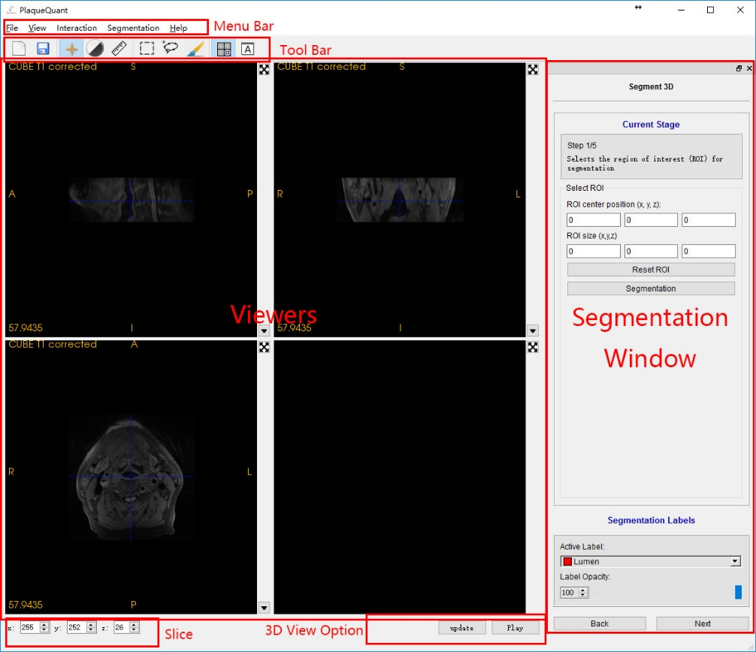

Tool bar:

In the tool bar, the software consists of 3 examining modes, 3 editing modes, 2 view models and the 2 basic function (open and save).

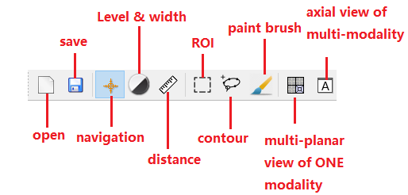

Figure Toolbar tooltips 1

|  |  |  |
| --- | --- | --- |
| **Functions** | | **Operations** |
| Open | * Open the registration wizard for loading images | |
| Save | * Open the saving wizard for saving the segmentation image | |
| **Views** | **Operations** | |
| Multi-planar view of one modality | * Display 3 different views (axial view, sagittal view, coronal view) in 3 viewers which are from the same MRI modality image. | |
| Axial view of multi-modality | * Display 3 views in 3 viewers of 3 different MRI modalities images all in axial view | |

|  |  |
| --- | --- |
| **Modes** | **Operations** |
| All | * Move middle wheel to change slice |
| Navigation | * Left click to select slices location * Hold right click to zoom * Hold middle click to move camera |
| Level & width | * Hold left click to control the window level and widow width of images. |
| Distance | * Left click to place a point and measure the distance between 2 points |
| ROI | * Left click to the blue sphere and drag it, 3 ROI frames will move synchronously * All voxels in the extent of 3 frames will be extracted for doing segmentation |
| Contour | * Left click to place a contour point * Hold left click to keep placing contour points * Right click to extract lumen wall (when auto lumen segmentation enabled) * Double left clicks to draw the contour with specified label |
| Paint brush | * Hold left click to draw with specified label. * Hold right click to erase label as an eraser |

Viewers:

Every viewer has a capital letter to represent its directions. (S: superior, I: interior, A: anterior, P: posterior, R: right, L: left)

Upper left is the modality name.

Lower left is the voxel intensity of the cursor.

Upper right is a button which can maximize the current viewer. (This button will change to return normal size when the viewer is maximized)

Lower right is a button “▼” for changing modality.

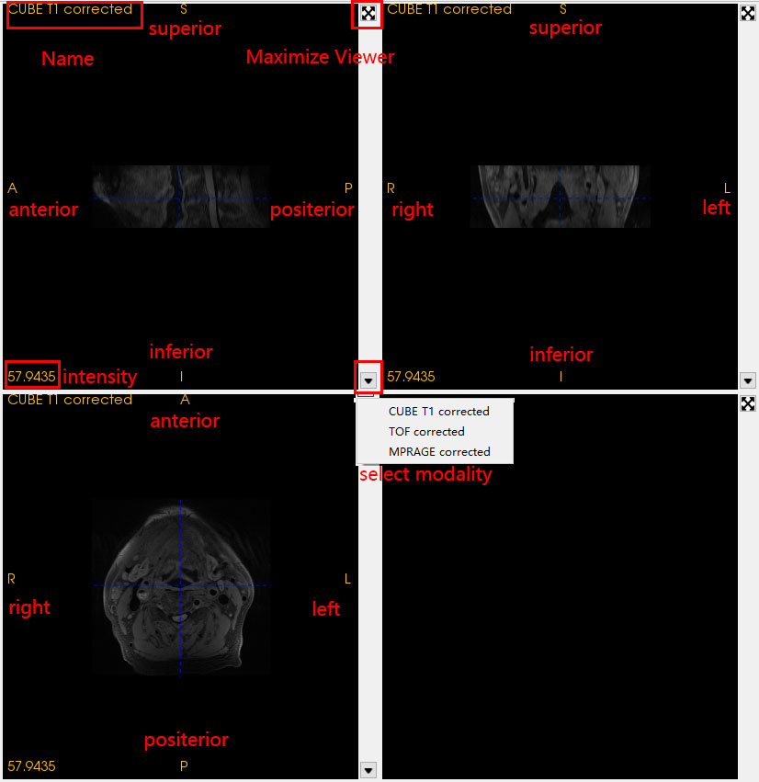

Segmentation Window:

On the upper part of the segmentation window can be change on different mode or click the “Next” or “Back” button on the bottom. The first 3 stages are the configurations of 3 editing modes (ROI, contour, paint brush). The last 2 stage are using for 2D and 3D numerical measurement and automatic report generating.

On the lower part, it is the setting of active label and its opacity. When the opacity of the label is changed, the relevant label of the viewers will be change synchronal.

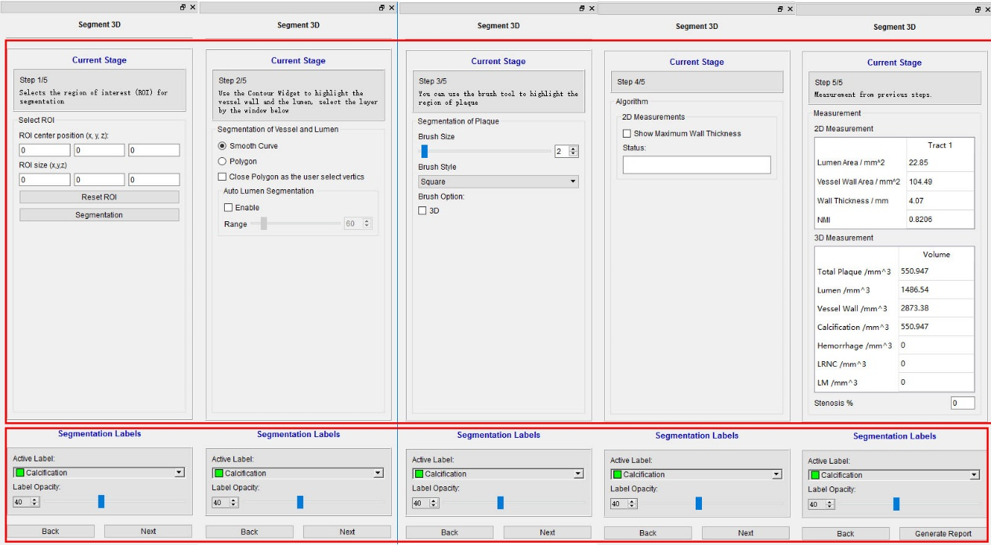

### Image Loading and Registration

Medical image loading can be performed by clicking “File” -> “Open Image” OR “Recent Image” in menu bar. Then the “Registration Wizard” will pop up. The software is able to load multi-modality MRI image in DICOM or NIFTI format. Other formats are still not yet supported. By clicking “Open Image”, user is supposed to select accurate folder which contains images to be loaded. By clicking “Recent Image”, user can select the recent folder in history.

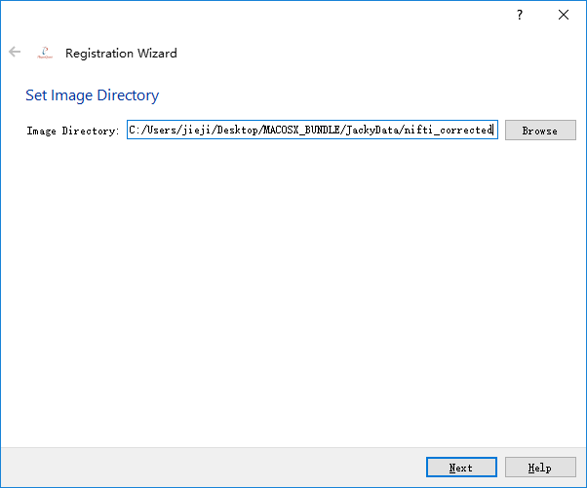

In the next, all supported image data are loaded into the upper table, user should follow hints of the wizard and select relevant images. By clicking “<<” the highlighted image will insert to the corresponding slot. While clicking “X”, the image in the corresponding slot will be removed. The software is capable to load 5 different modalities MRI image (CUBE T1 image，CUBE T2 image，CUBE T1 + Contrast, 2D Double Inversion Recovery(DIR)/Quadruple inversion recovery(QIR), MPRAGE).

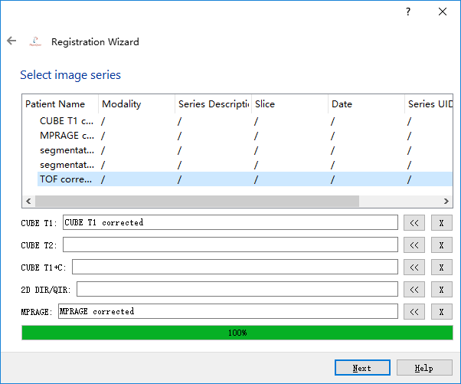

In the next, properties of the selected images are displayed and user can do the final confirm whether they are the correct image to be loaded (Only for DICOM, NIFTI do not have these properties). If not, user is capable to click the “<-” in the upper left to return previous wizards. If nothing goes wrong, user can click the “finish” and the software begins to load image and do the registration, which should be taken a few seconds. Please don’t be panic if the software is not responding.

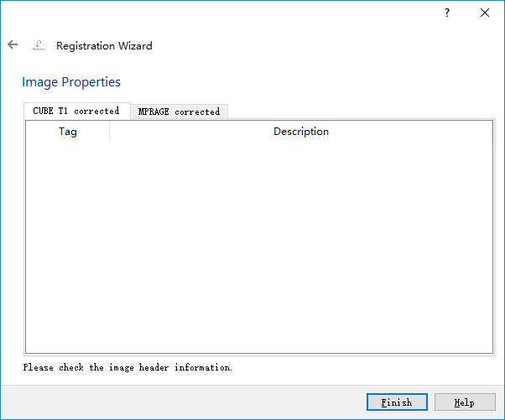

Figure Function tab options - Image Preprocessing

### Image View

As it has already been written in 3.1, Multi-planar view of one modality and Axial view of multi-modality are 2 views for user to browse their images.

1. Multi-planar view of one modality

On upper right it is a sagittal view. On upper left it is a coronal view. On lower left it is an axial view. All three viewers are displaying the same modality image.



1. Axial view of multi-modality

Three viewers are displaying different modalities and all of them are in axial view. Normally, vessel wall and lumen are easily recognizable in axial view.

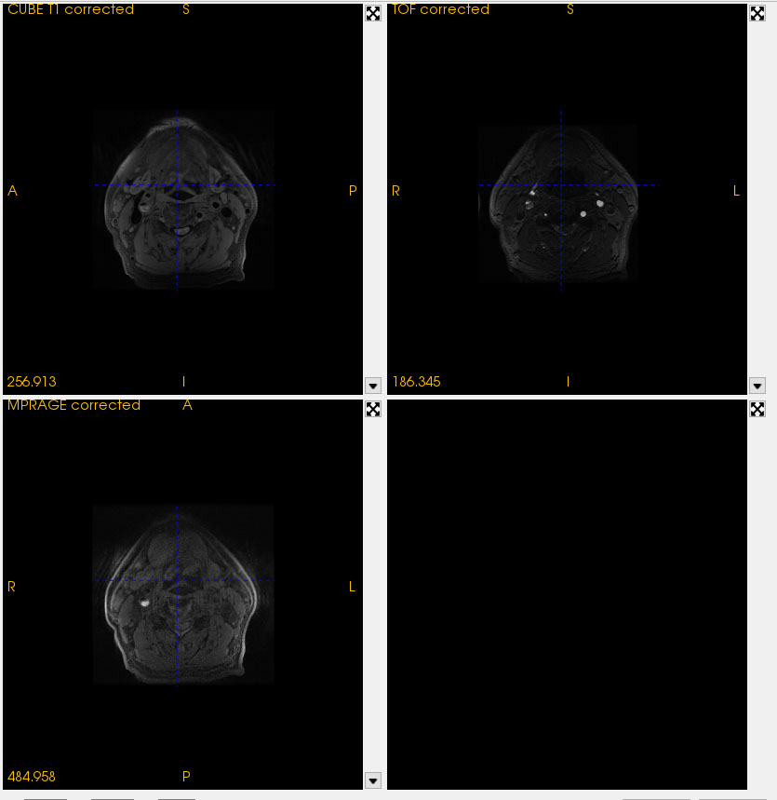

### Image Examining

As it has already been written in 3.1, Navigation mode, level & width mode and distance mode are 3 modes for user to examine their images.

1. Navigation

Holding left click: drag the blue cursor and the intensity in the lower left will update synchronously.

Middle button: drag the image position.

Holding right click: up to zoom-in, down to zoom-out.

Keyboard “r”: reset the image position.

1. Level & Width

Holding left click: change the viewer’s window level and window width. While moving vertically, the window level will change. While moving horizontally, the window width will change.

1. Distance Measurement

The first left clicks: place a begin point of the distance widget.

The second left click: place an end point of the distance widget.

Both points have been placed: left click to drag one of those point to alter points’ positions.

### Image Editing

As it has already been written in 3.1, ROI mode, contour mode and paint brush mode are 3 modes for user to do segmentation. User is supposed to follow the hint on the right. Extracting ROI(Optional) -> Using contour widget for doing segmentation -> Using paint brush for optimizing segmentation

1. ROI(Optional)

In this mode, user is supposed to select their region of interesting for segmentation, but this is not compulsory.

In every view, the frame has 4 blue spheres which are used as change its sizes. Anytime the size of the frame is changed, its configuration will be updated on the right.

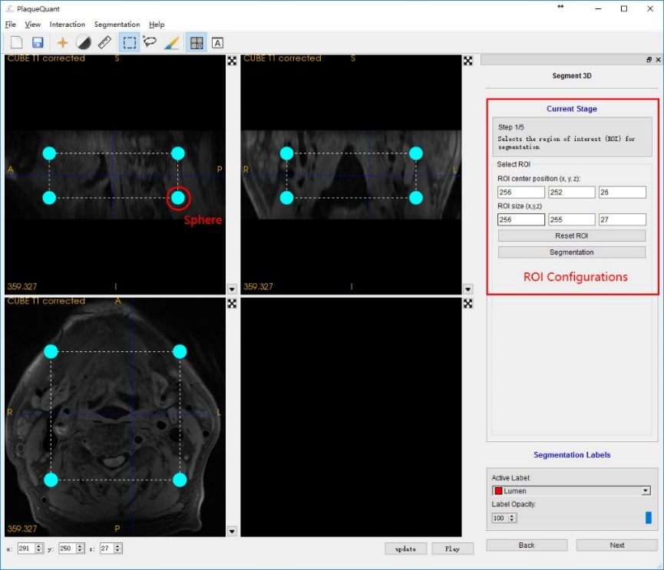

After finishing changing the frame, user can click segmentation to extract the ROI.

If user is not satisfied, please click Reset ROI again and redo the upper procedures.

1. Contour

In this mode, user is supposed to use contour to do the lumen and vessel wall segmentation.

Normally the vessel wall and lumen are easily recognizable in axial view. So user is suggested to only using contour in axial-view viewer or change to axial view of multi-modality. User is also suggested to maximize the working viewer for better performance (3.1 viewer).

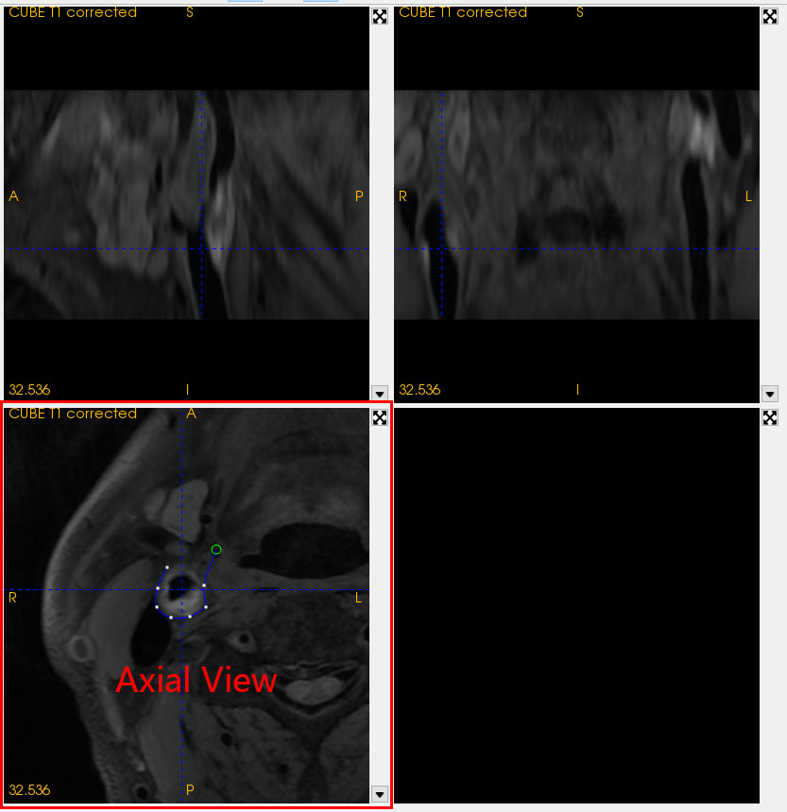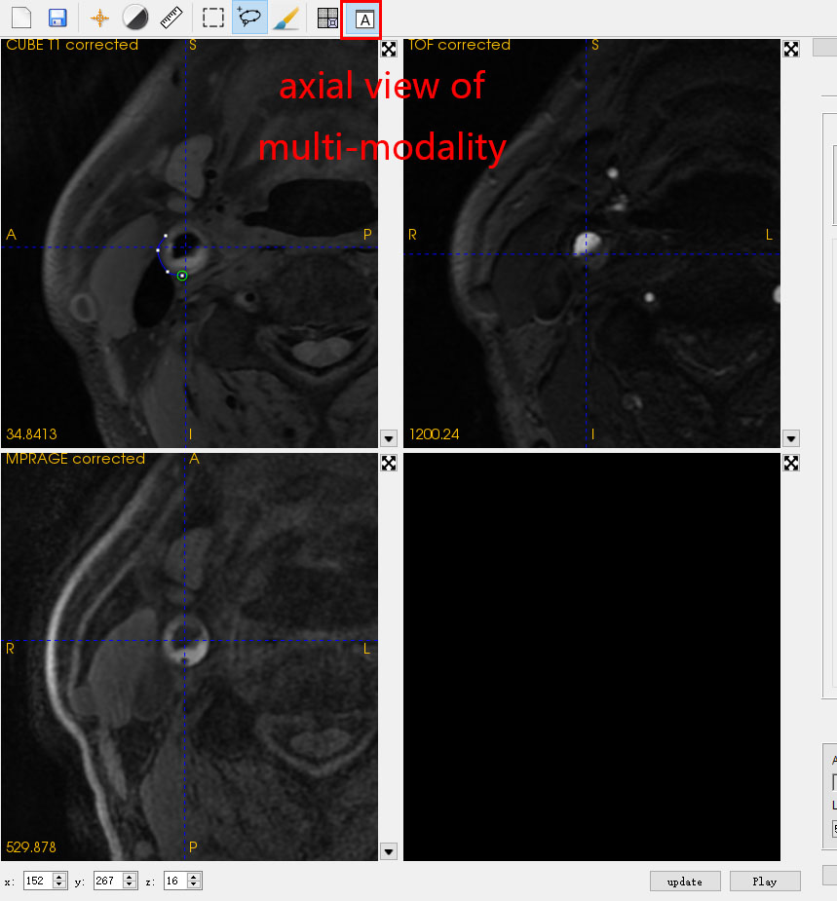

One the right is the configuration of contour mode. User can select using polyline contour or smooth curve contour to do segmentation. The software also purposes an algorithm for doing lumen segmentation. User just need enabled it and provide the vessel wall contour with appropriate threshold rage, the software will automatically find the lumen contour. The lower part is for selecting segmentation labels. While auto lumen segmentation is enabled, the labels will be automatically selected for user.

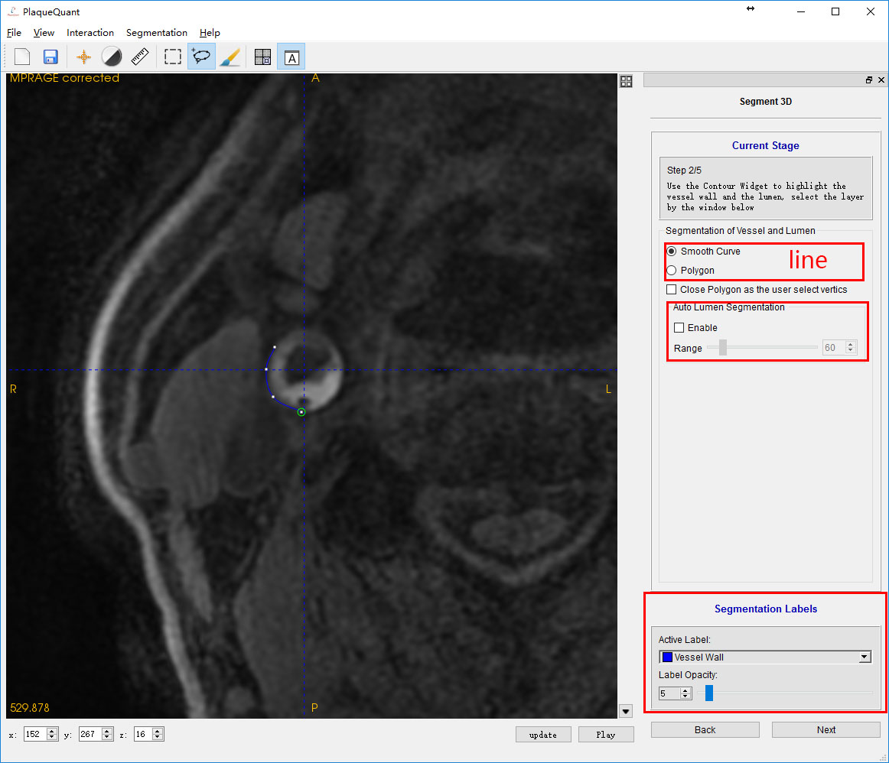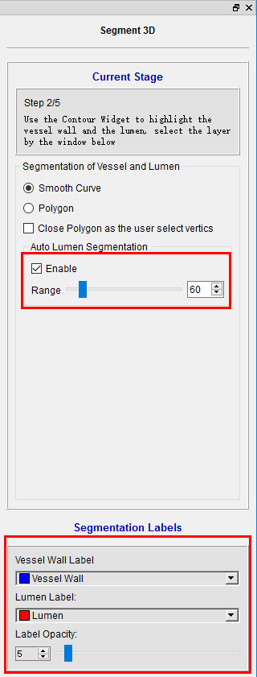

Anytime:

Keyboard “Enter”: close loop and do segmentation with active label

Keyboard “Esc”: delete the whole contour widget

Before closing loop:

Left click: Placing a contour node. When the cursor is close to the first node, it close loop.

Holding left click: Continuously placing contour nodes.

Right double clicks: Close loop.

Keyboard “Delete”: Delete last contour node.

After closing loop:

left click: When the cursor is close to the contour line instead of node, add a new node. When it is close to a node, holding left click can alter a node’s position.

Left double clicks: Do segmentation with active label.

Keyboard “Delete”: Delete the node which is close to the cursor

Auto lumen segmentation enabled:

The same as above instead of the following:

Before closing loop:

Right double clicks: Close loop and generate lumen contour (If no lumen is found, user can define their own lumen).

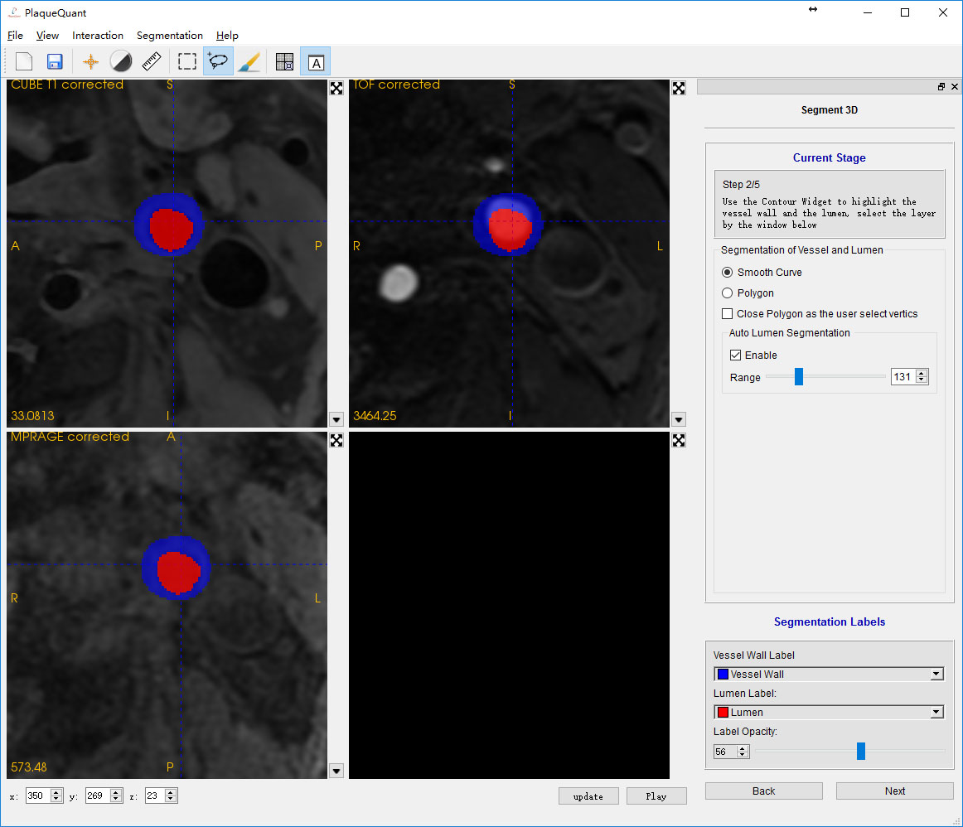

In axial view of multi-modality mode, user can compare the segmentation result in different modality.

1. Paint brush

In this mode, user is supposed to use paint brush to optimize their segmentation result.

Paint brush is a quite straight forward widget for user to do segmentation. However, it is too time consuming to do all segmentation manually. Using contour should be the best option. But user can still use paint brush to optimize their segmentation and add other label, such as calcification, hemorrhage.

On the right side is the paint brush configuration. User can change the brush size and brush shape. The lower part is for selecting paint brush label.

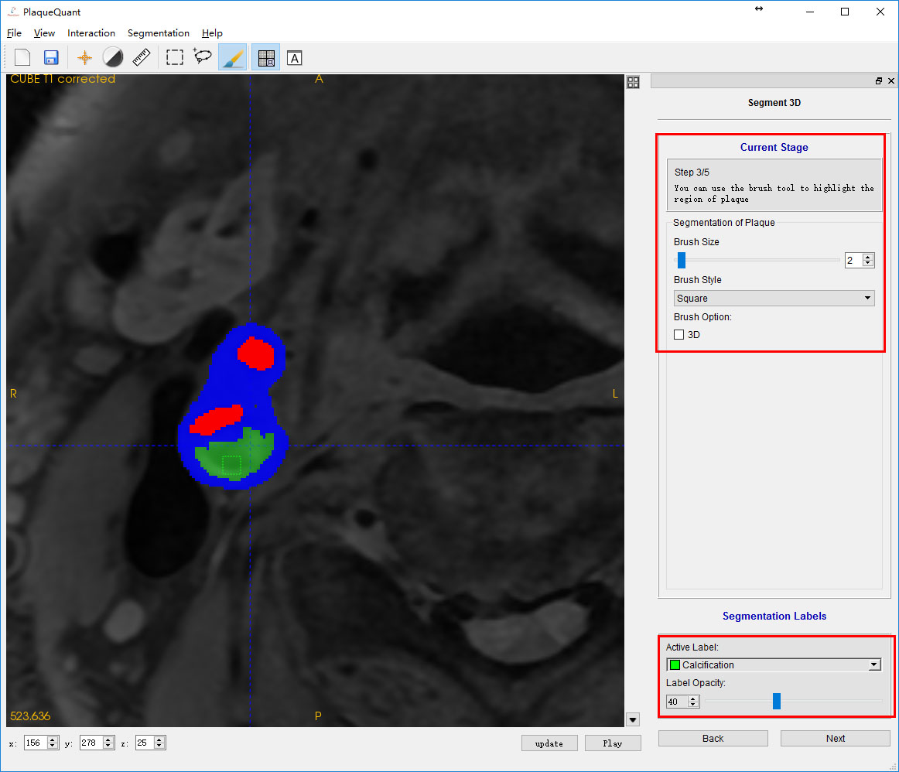

Holding left click: Draw with the active label.

Holding right click: erase the label and replace with nothing.

### 2D & 3D Numerical Measurements

#### Registration

To register the image, user can follow these steps:

1. Manually align the images roughly.
2. Choose fix image and moving image in the panel at the right-hand-side (Figure 6).

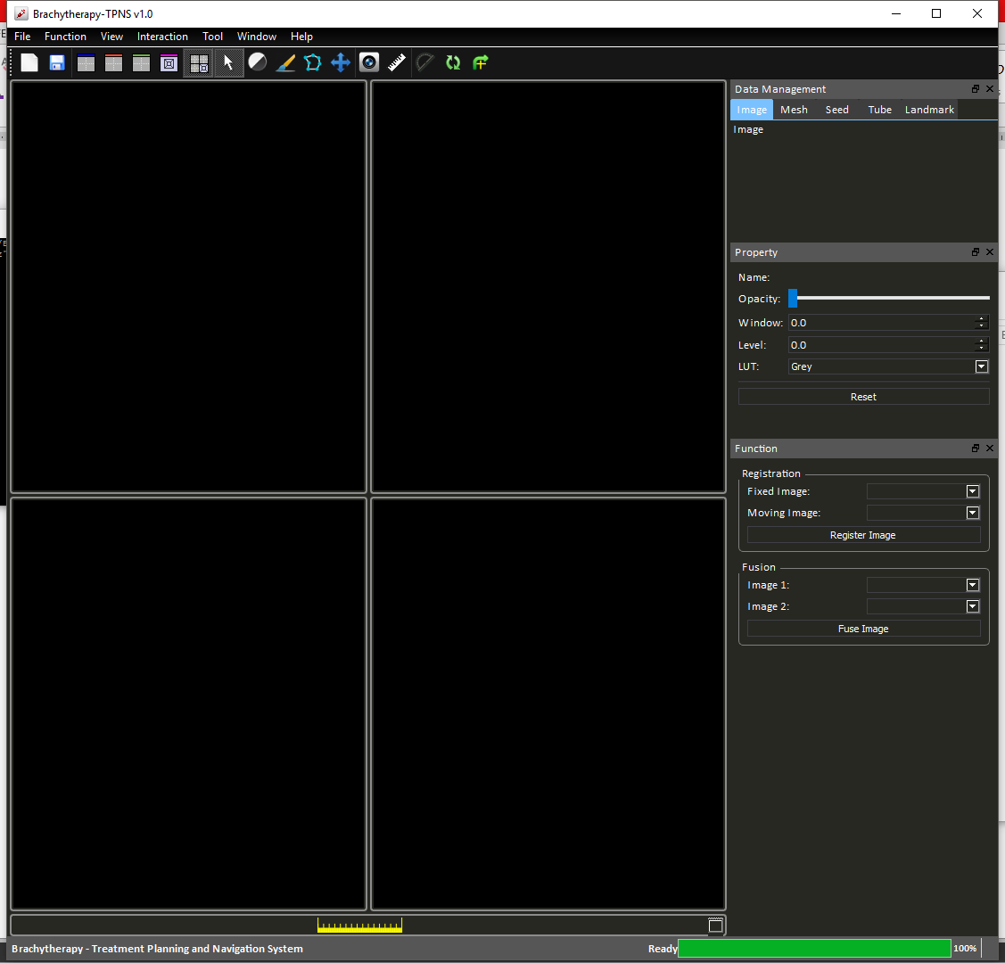

Figure Registration properties

1. Press “Register Image”.

This process may take 5-20 seconds depend on the quality of the initial alignment. If the result is not satisfactory, user can perform a series of registrations by repeating the upper steps.

#### Image Fusion and Exporting Images

To fuse two images into one weight sum image, user can follow these steps:

1. Select images to be fused.

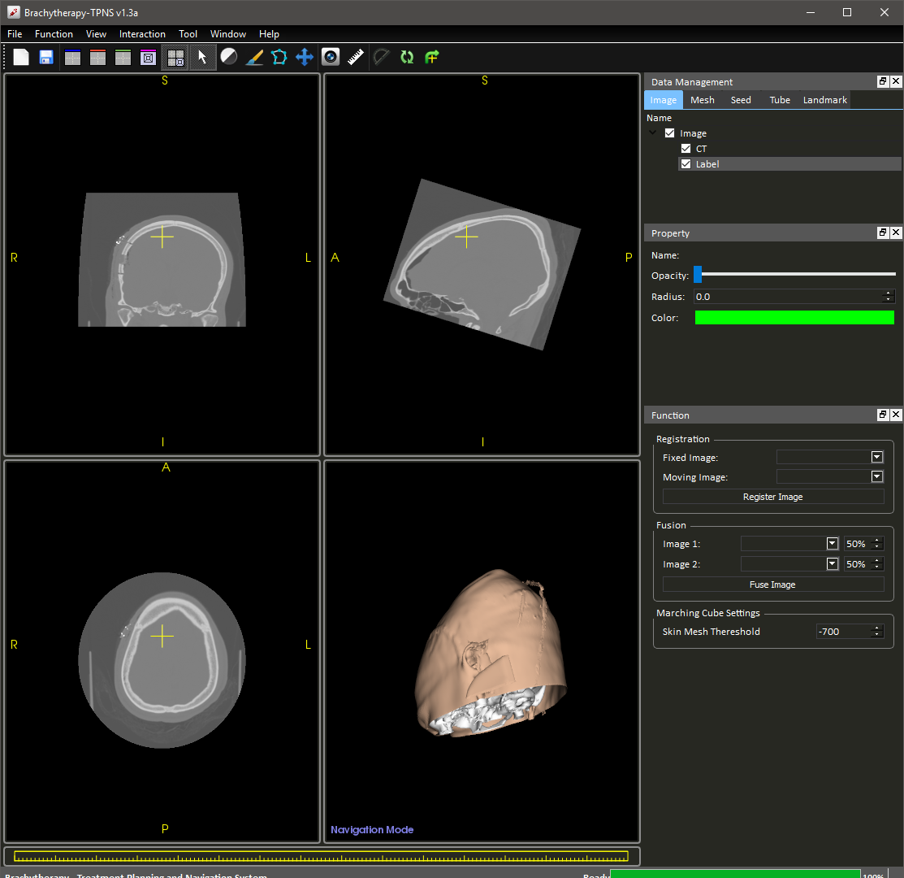

Figure Image fusion properties

1. Press “Fuse Image”

A new image data will be created as the 50-50 weighted sum of the two selected images (Figure 8). The weight constant can be adjusted by changing the percentage value at the right hand side.

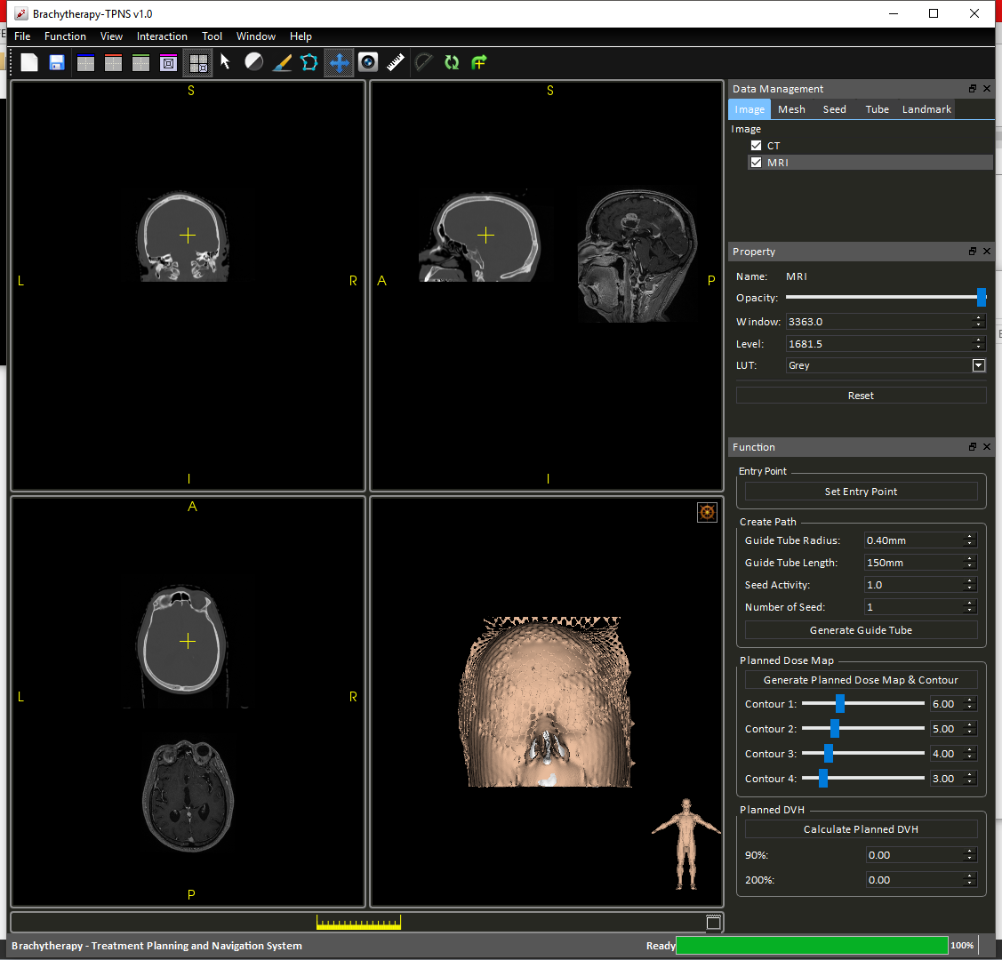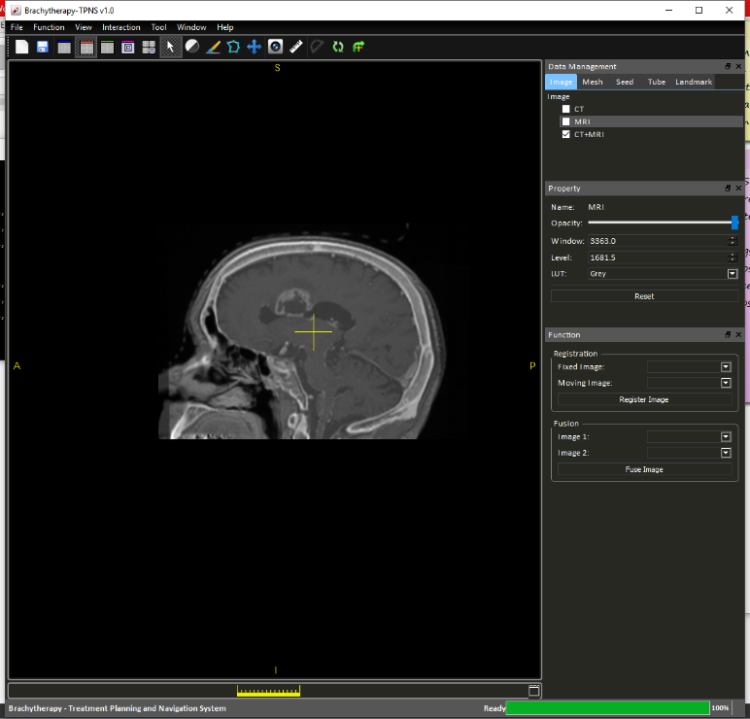

Figure Image fusion describe

To export the fused image, right click on the image “CT+MRI” on the “Data Management Panel” and select “Export as DICOM/NIFTI”.

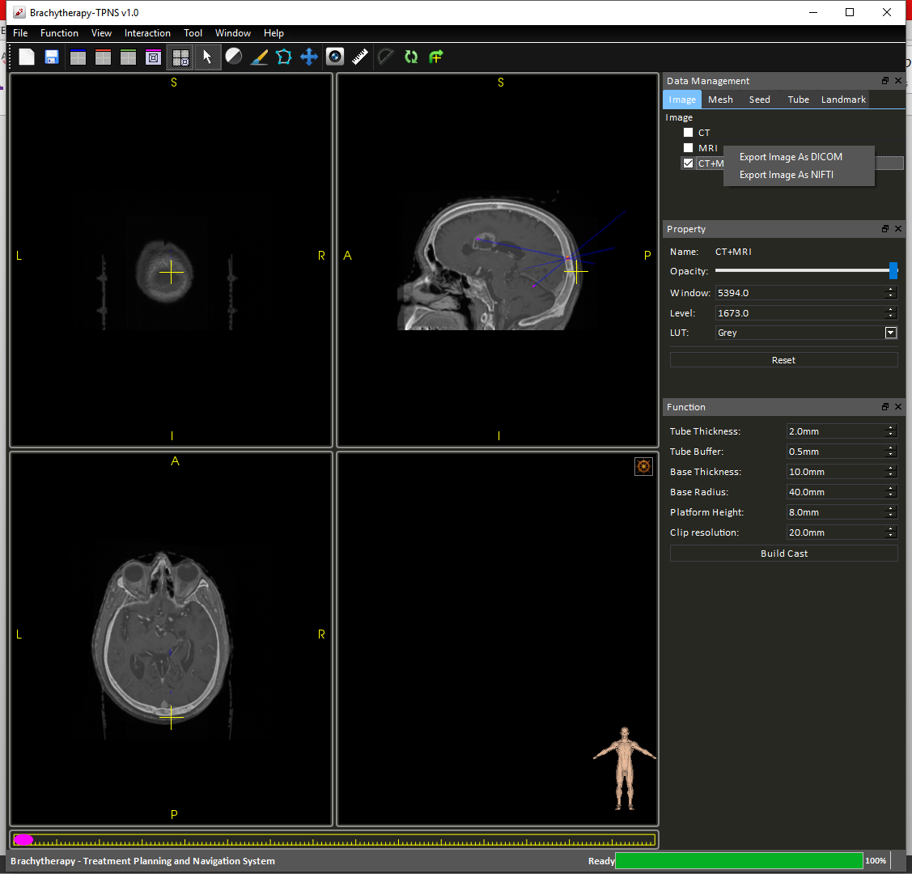

Figure Export images

#### Mesh Marching Cube Settings

Cast building in latter steps uses the skin mesh as the basis. To guarantee a good quality surgical guide, you should adjust the marching cube threshold and examine the mesh before proceeding. User can achieve this by adjusting the following parameter in the right-hand-side panel (Figure 10):

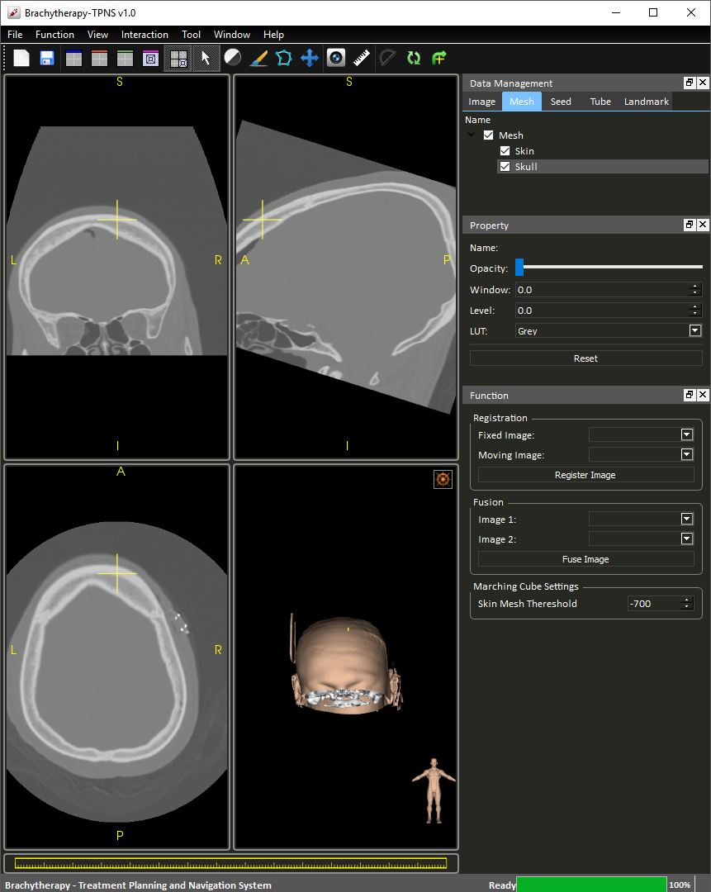

Figure Marching Cube Setting

### Image Segmentation

To carry out segmentation, a label map has to be created if not pre-loaded. This can be done by clicking the “Image Segmentation” as in

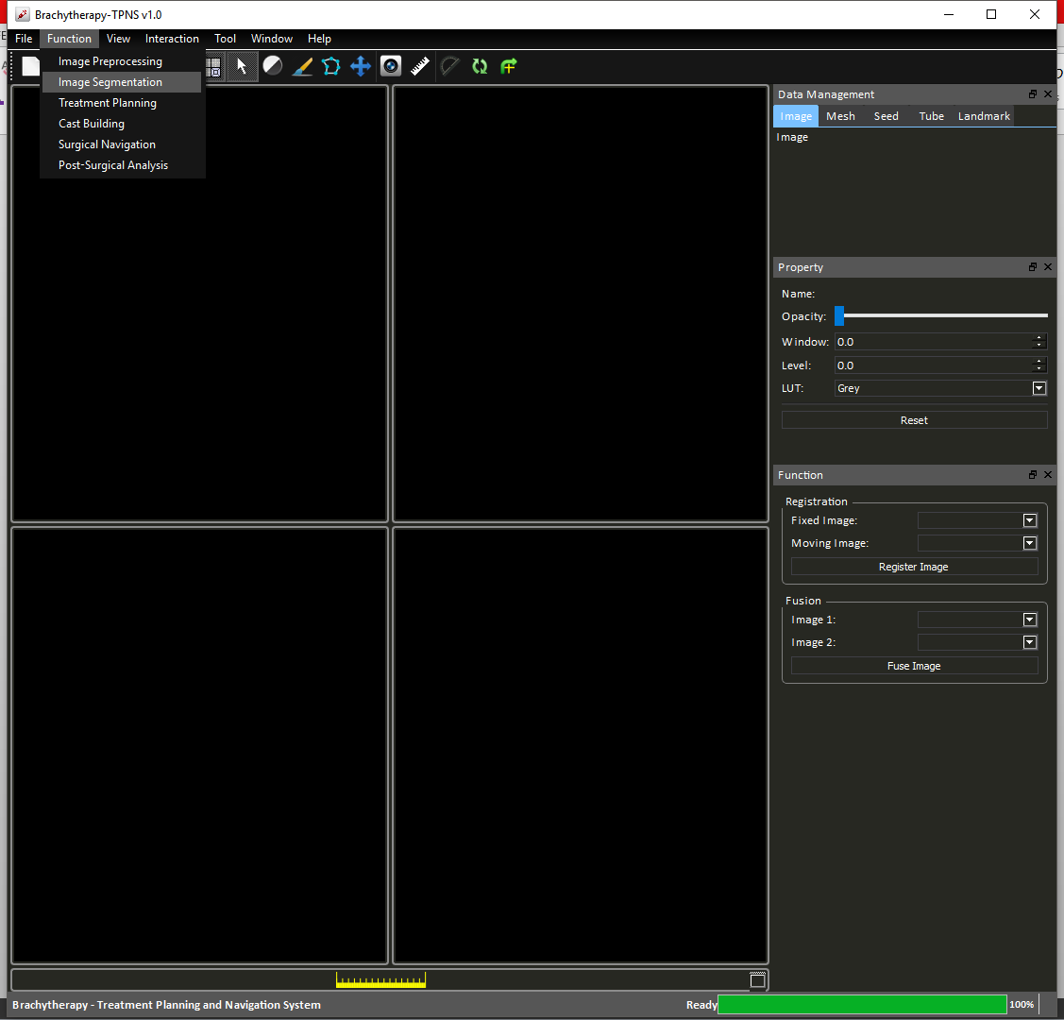

Figure Function tab options - Image Segmentation

A property tab will appear at the right of the user interface for adjusting brush properties.

#### Drawing

Press the painter to activate “Draw” mode, right click on the targeted region to draw labels and left click to erase the labels. Note that when “Draw” mode is activate, the direction of the image is temporally cleared. It is also recommended that user first fuse the images before segmentation due to restriction of reslicer.

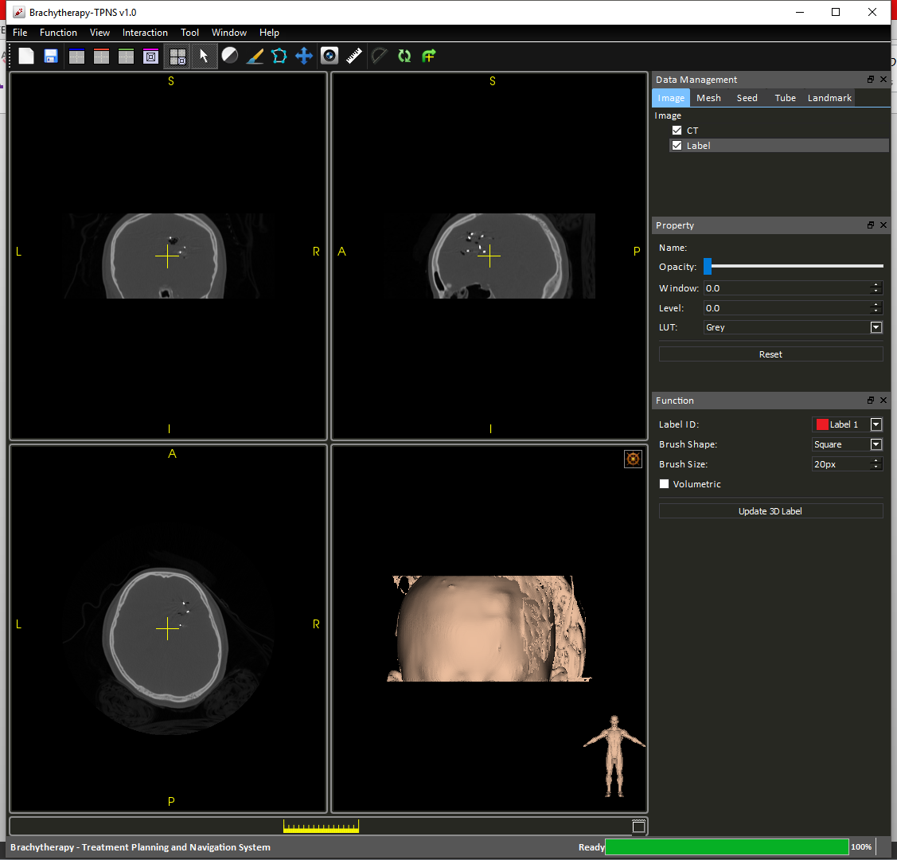

Figure Segmentation properties

Brush shape refers to the shape of the drawn label, currently user can select between square and circle (Figure 12). Brush size refers to the pixel length of the sides/diameter of the drawn label.

### Treatment planning

Treatment planning is initiated by selecting “Treatment Planning” option under “Functions tab (Figure 13).

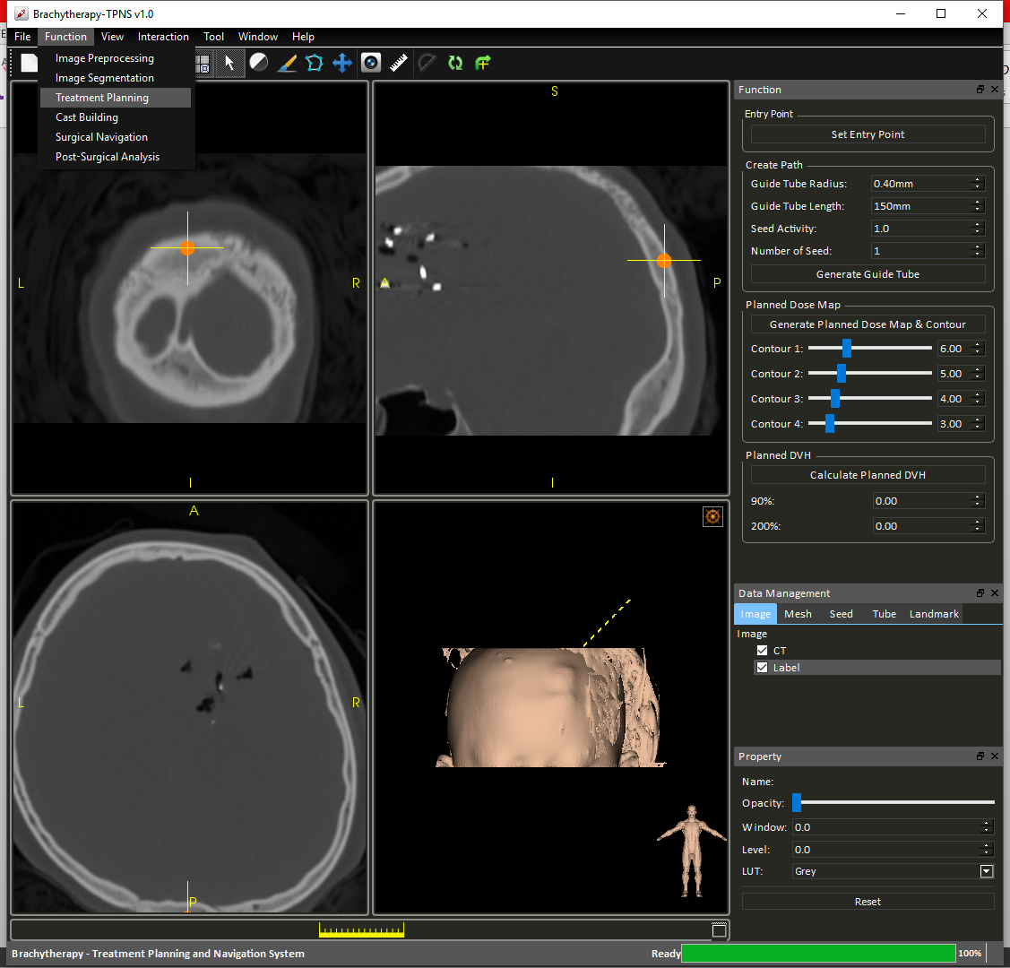

Figure Function tab options - Treatment Planning

#### Placing guide tubes and seeds

Seed placing planning typically involve three steps:

**Step 1**: Select entry point in “View” mode, press “Set Entry Point”.

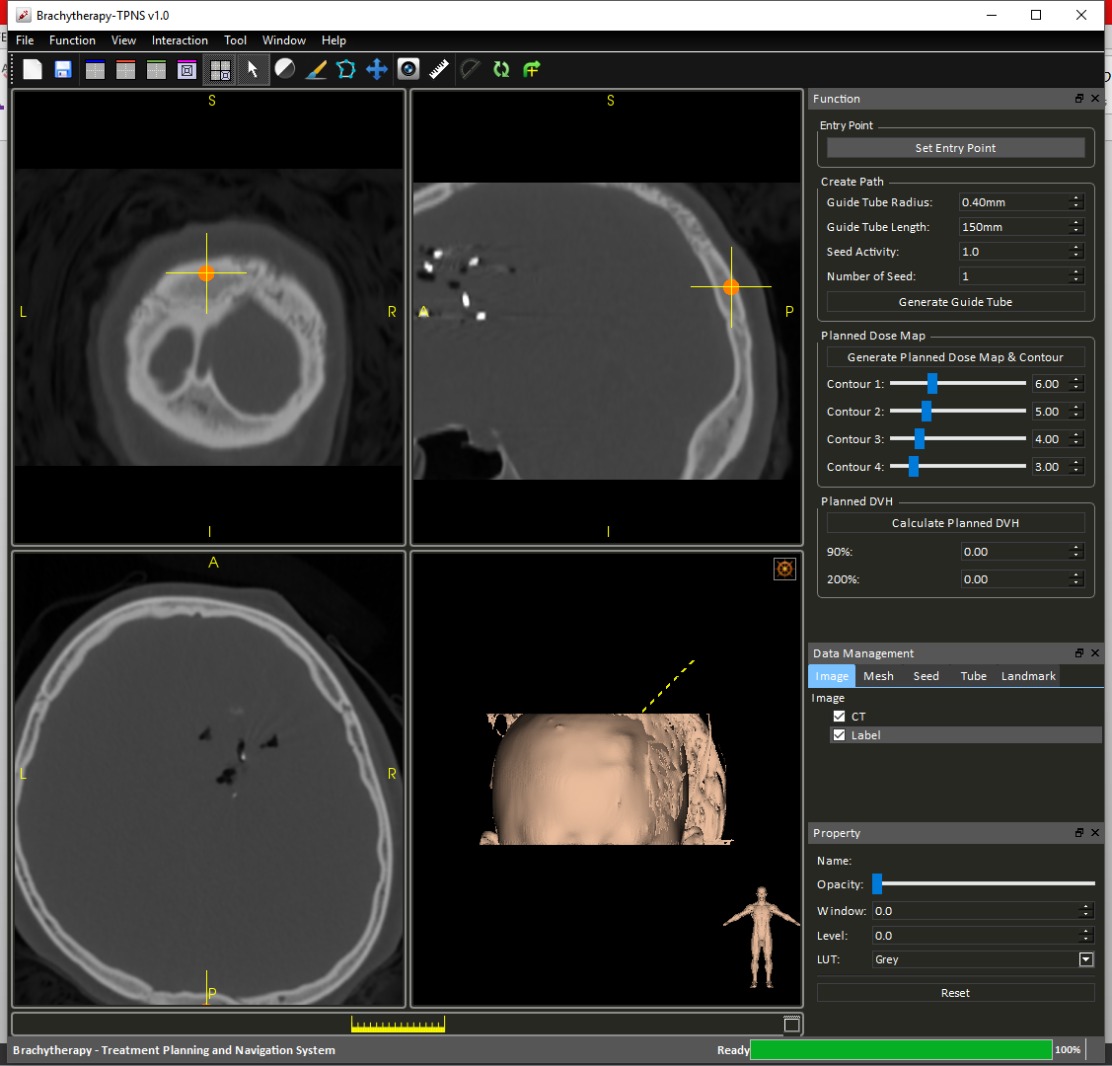

Figure Set Entry Point

**Step 2**: Modify seeds properties and number of seeds.

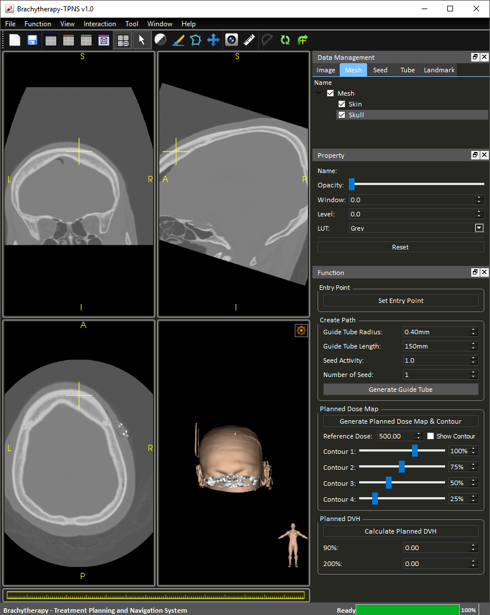

Figure Adjust seed properties

**Step 3**: Select end point of insertion tool, press “Generate Guide Tube”.

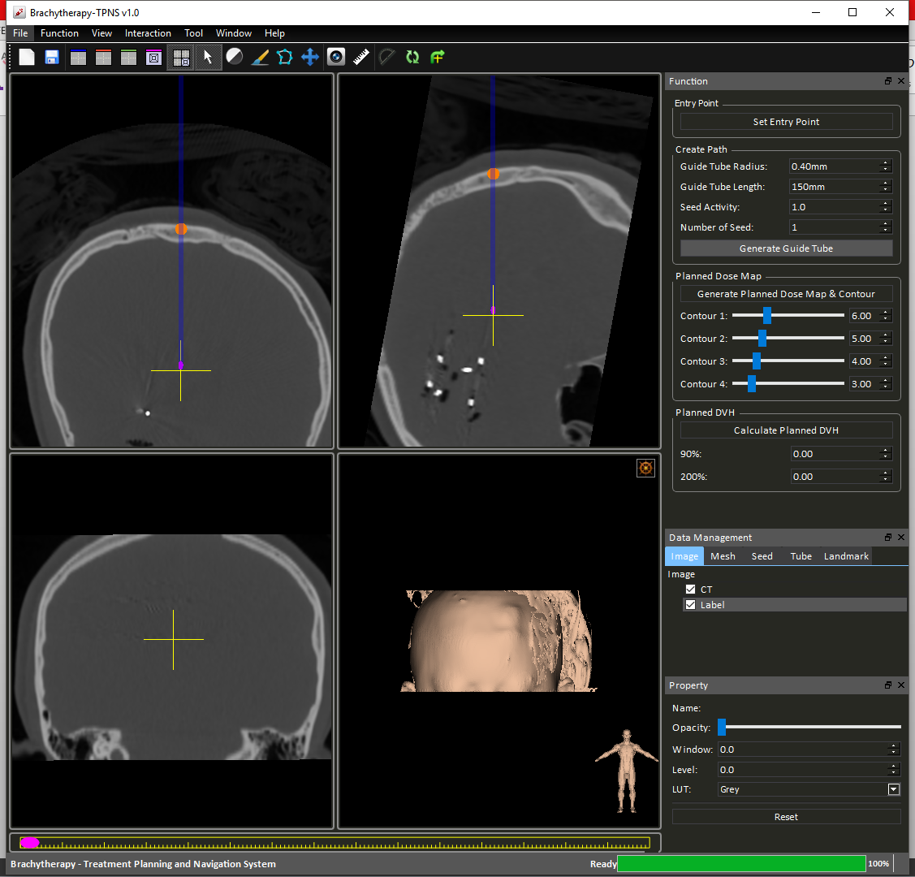

Figure Generate Guide Tube

Once the guide tube is placed, the camera will automatically provide the oblique (Figure 16) view of the tube based on its orientation. User can resume normal view by pressing the right-most “Reset View Plane” button to reset the view plane to follow the x-y-z orientation.

A widget (Figure 17) at the bottom of the view ports allows operations including moving seeds position within its guide tubes, add/remove seeds and removing the tube.

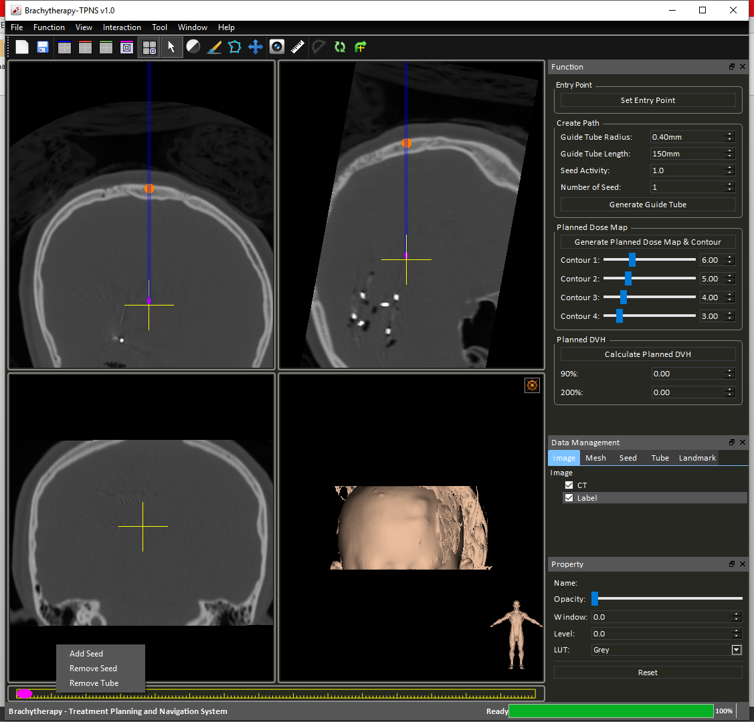

Figure Guide tube control widget

By dragging the location of the purple seeds within the selected guide tube, user can determine the location of the seeds relative to the tube.

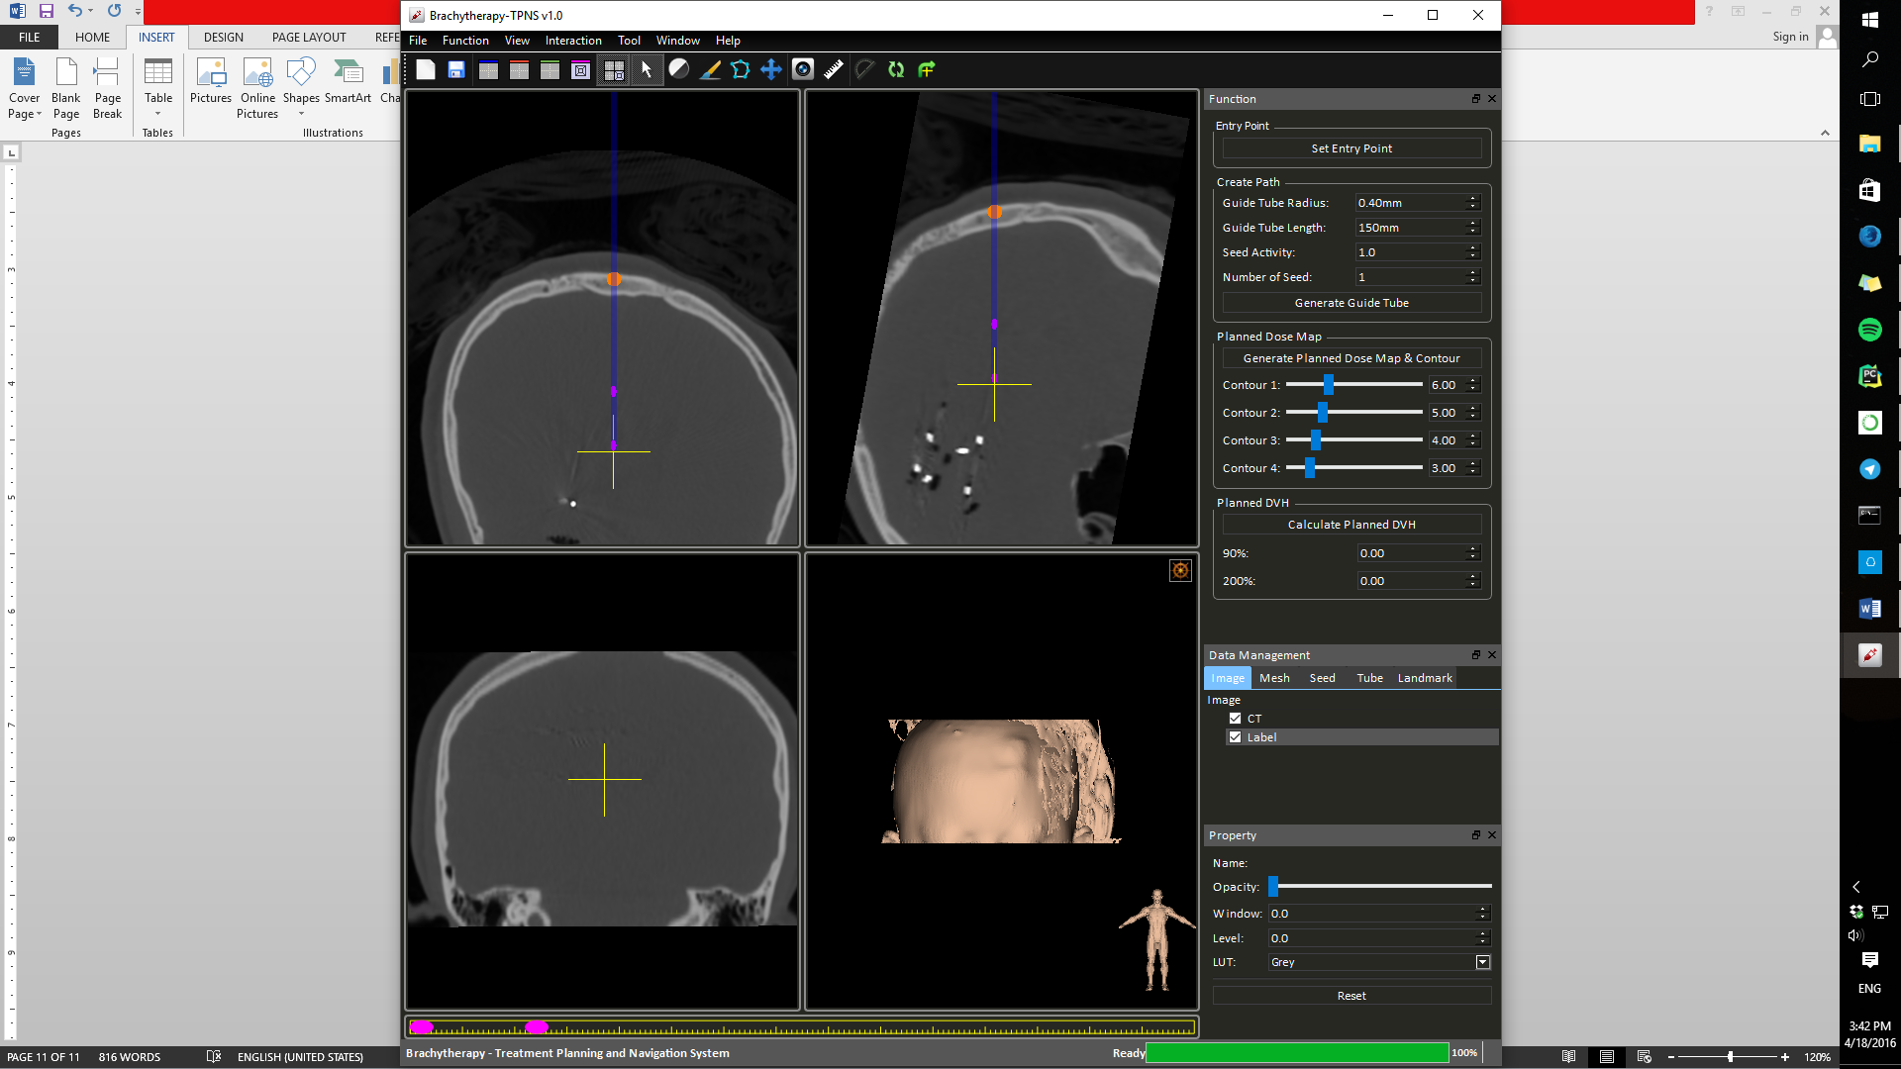

Figure Moving Seeds

Repeat **Step 3** to create more guide tubes. Note that there are no restriction to the plane normal of seeds placing.

#### Dosemap and Contour Generation

A dosemap of the current seed configuration can be generated by clicking the “Generate Planned Dose Map & Contour” button (Figure 19).



Figure Generate Planned Dose Map & Contour

The contour based on the assigned values will also be generated and displayed in the view ports (Figure 20).

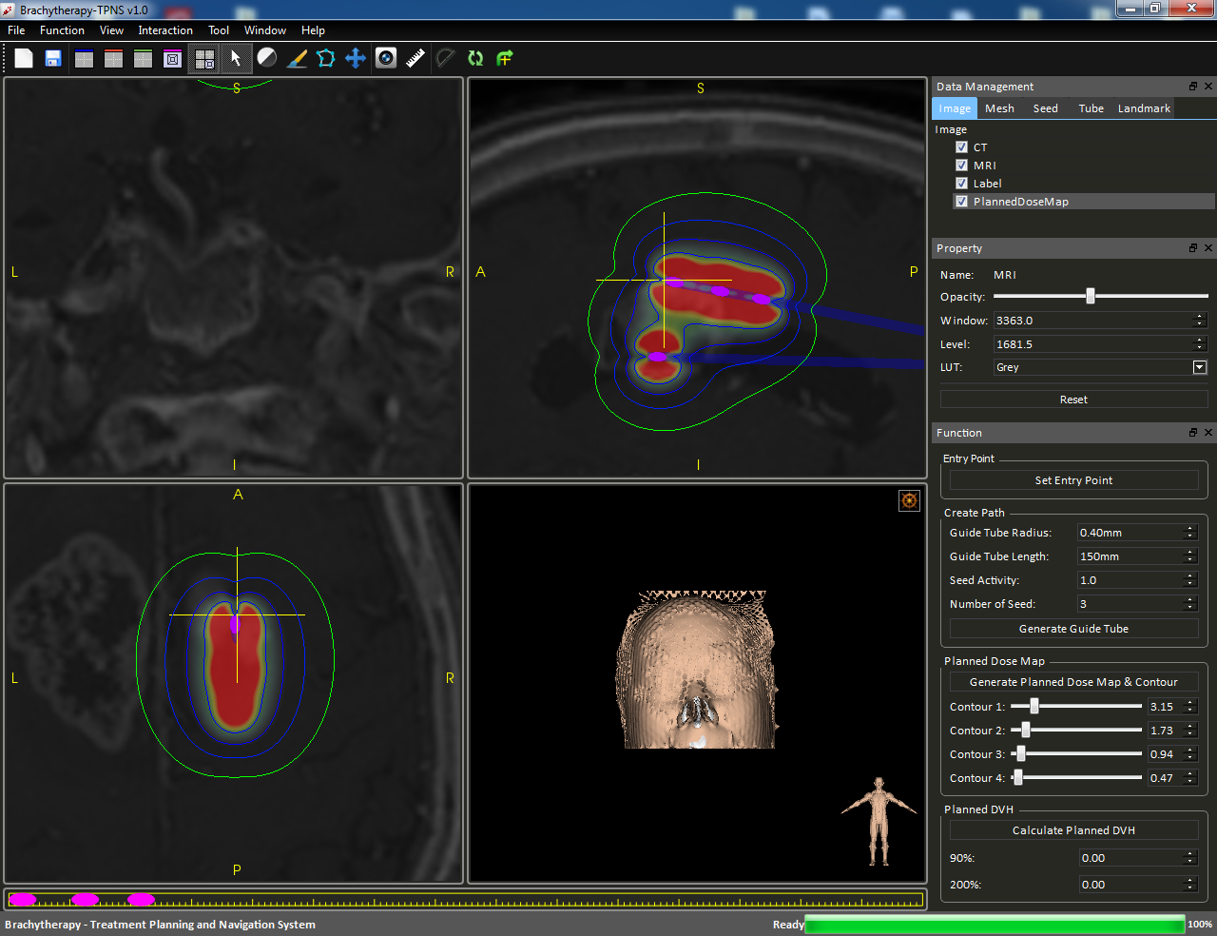

Figure Dosemap with contour

Use can click on the “Show Contour” check box in Figure 19 to toggle the contour for faster interactions.

#### Dose Volume Histogram (DVH)

After segmentation and generation of dosemap, a DVH can be produced by pressing the “Calculate Planned DVH” button.

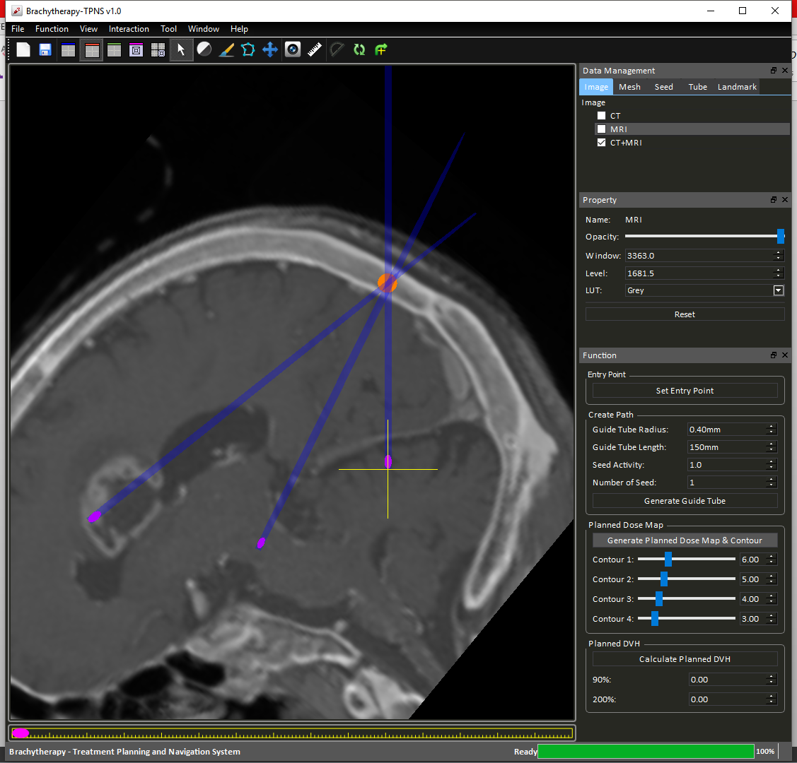

Figure Calculate Planned DVH

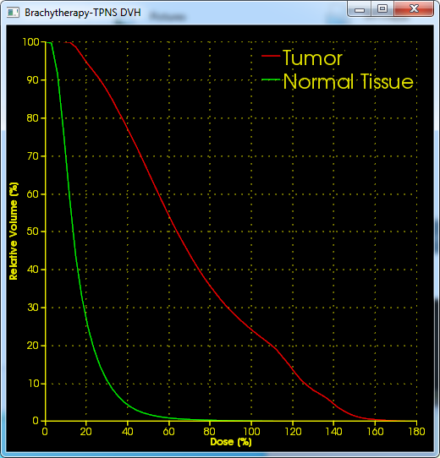

Figure DVH illustration

#### Cast Building

A surgical guiding cast can be generated by selecting “Cast Build” option under the “Function” tab (Figure 23).

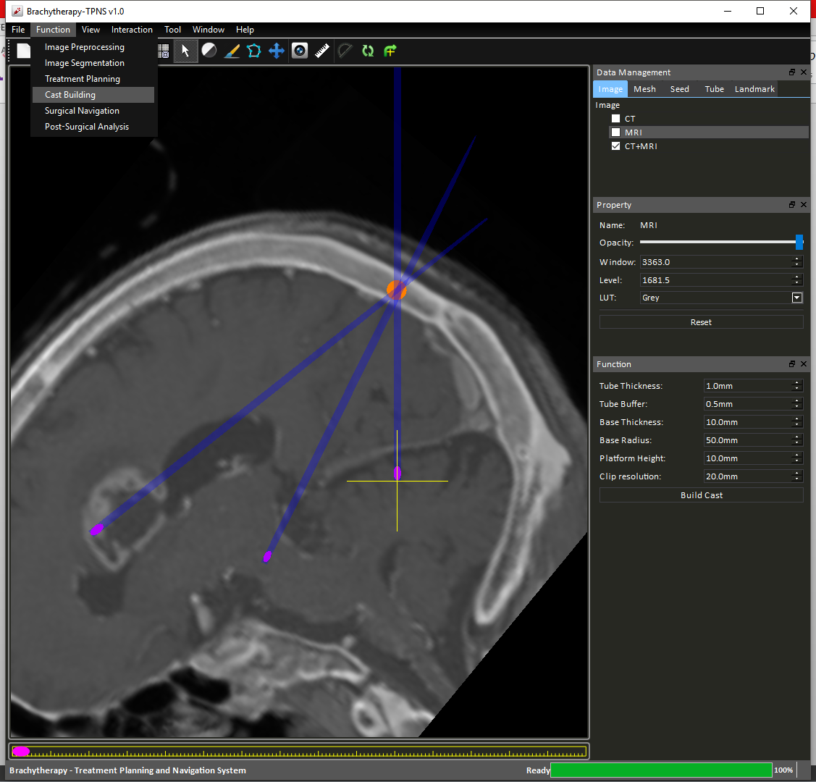

Figure Function tab options - Cast Building

Then press the “Build Cast” button on the panel (**Figure 24**).



Figure Build Cast Properties

A cast will then be automatically built (Figure 25), if error comes up, adjust the property of the cast according to the error message.

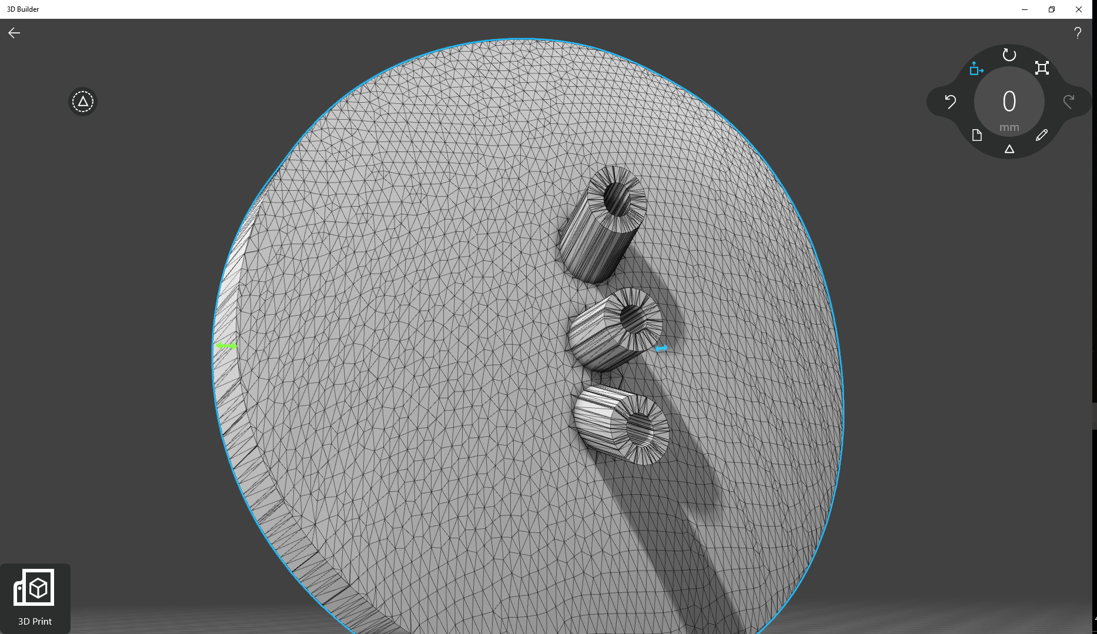

Figure Cast Mesh Product

To export the cast as STL file, simply right click on the mesh desired in the “Data Management Panel” and select “Export Mesh” (Figure 26).

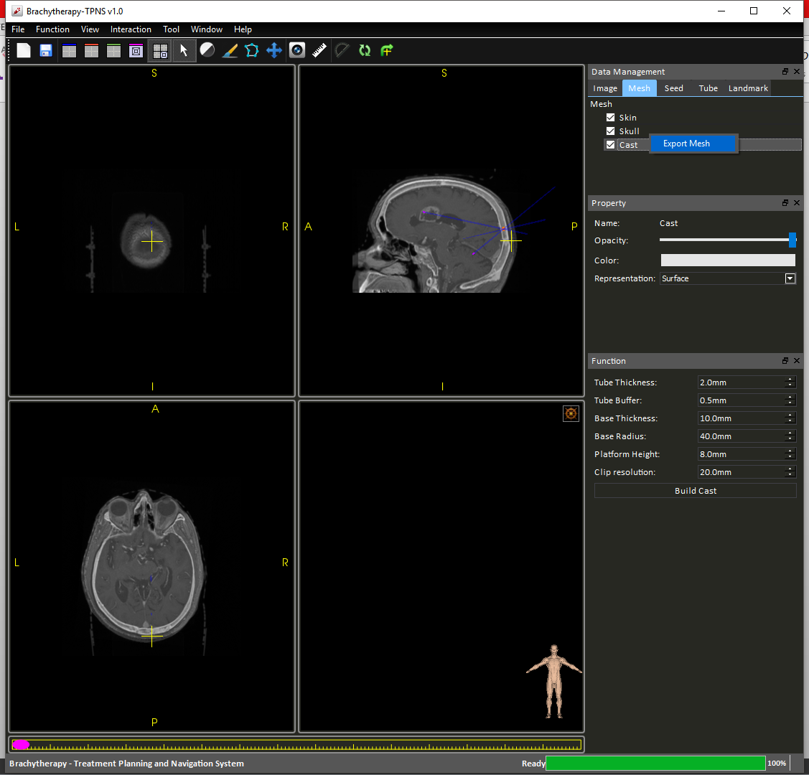

Figure Export Mesh

#### Marker Holes Generation

Holes can be added to the cast for aligning cast with pre-defined markers. In the same “Cast Build” option under “Functions” tab (Figure 23), there is an “Advance” panel (Figure 27).

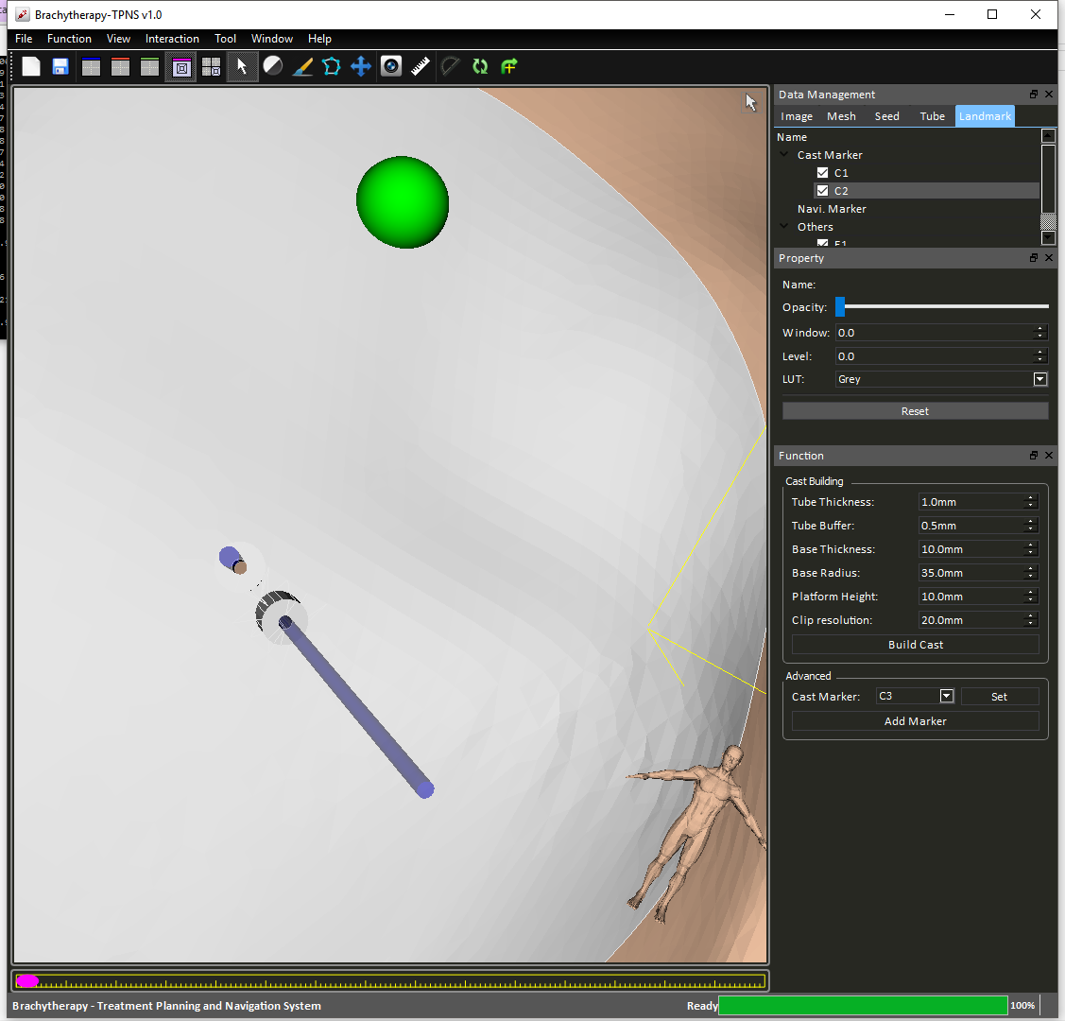

Figure Advance marker options

User can pin point the location in “View” mode, select cast marker labels “C1”, “C2” ... and then press “Set” to set a marker for holes punching. The marker appears as a green sphere in the 3D view port (Figure 28).

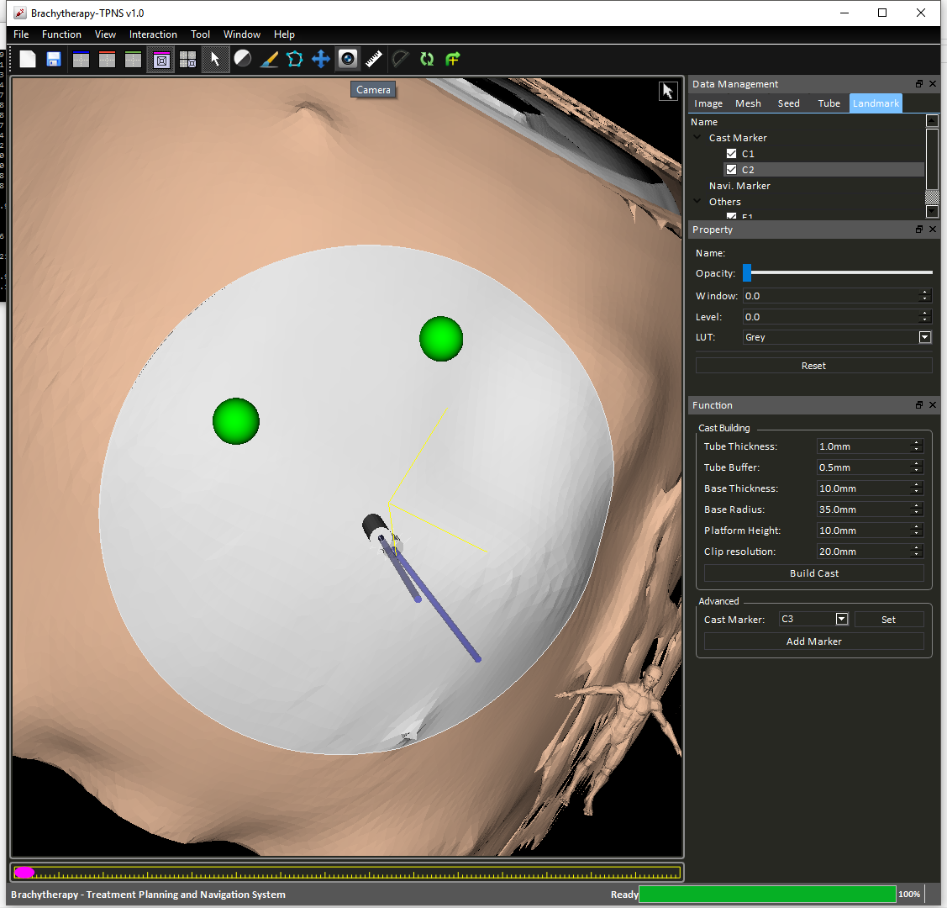

Figure Holes punching

Once holes configuration is done, press the “Add Marker” button in the right-hand-side-panel. A mesh with holes will be generate with the name “MarkedCast” (Figure 29).

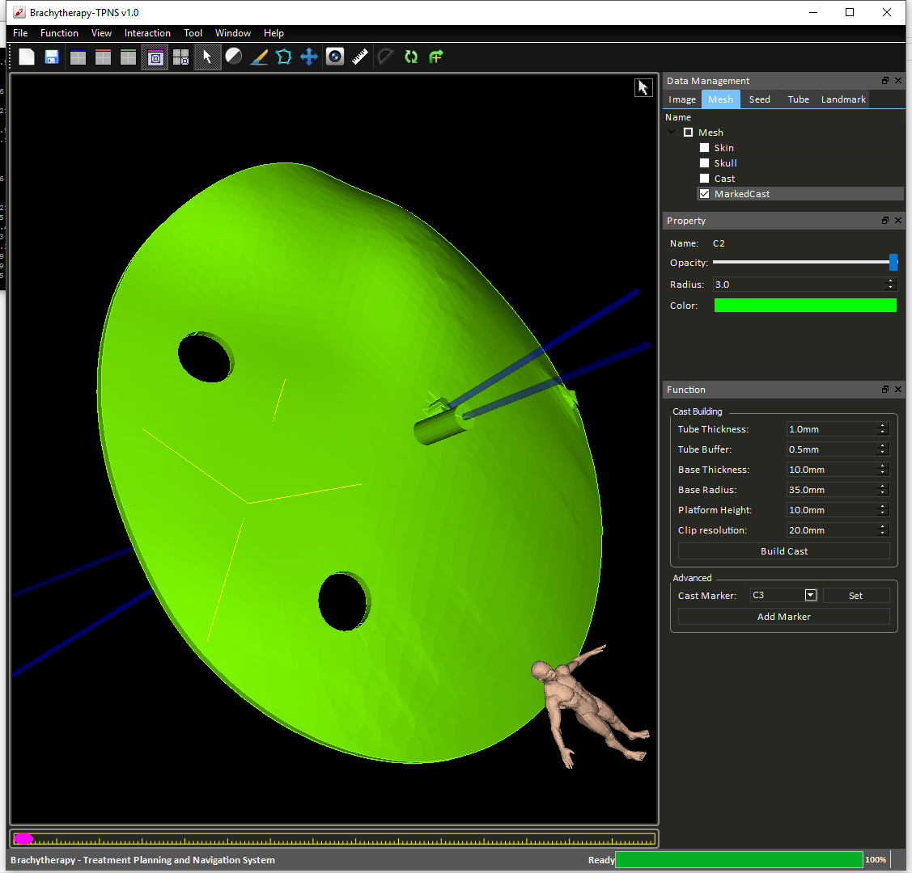

Figure Marked Cast Mesh

### Post-surgical Analysis

Post-surgery analysis can be performed by clicking the “Post-Surgical Analysis” option under the “Functions” tab.

User would have to provide a post-surgical CT image first by clicking “Add Intra CT Image” button (Figure 30) and select the corresponding image from their own database.

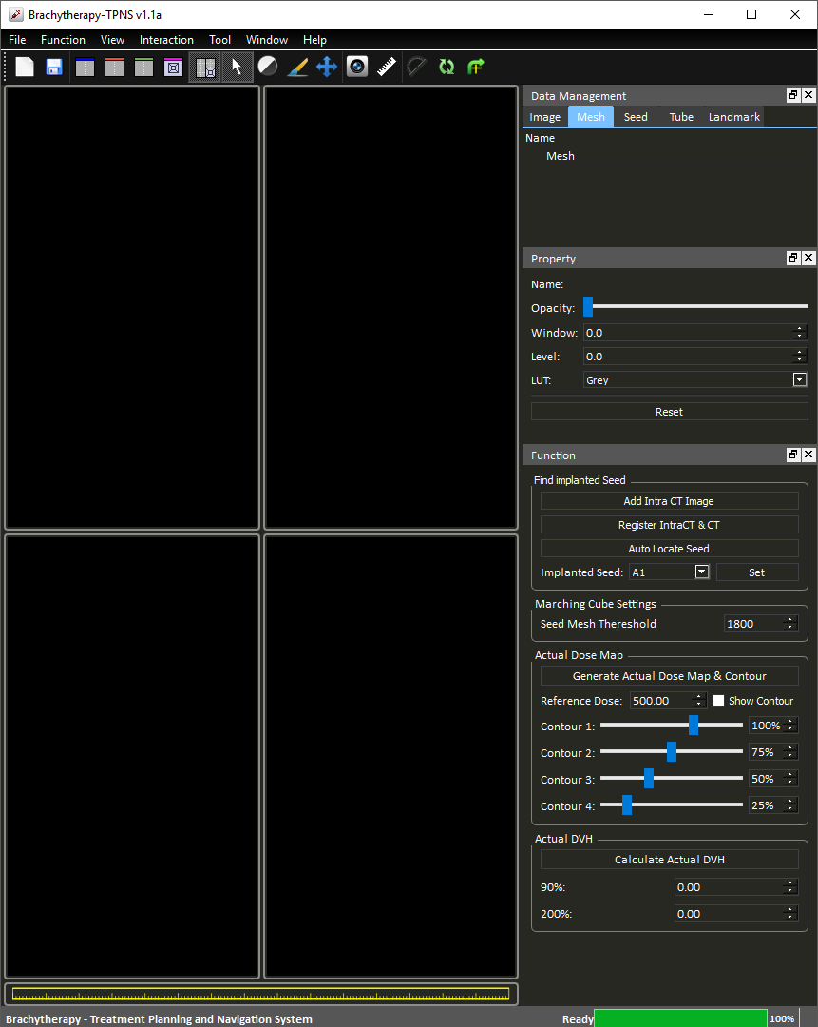

Figure Post-Surgical Analysis Panel

A short cut button is provide here for user to register the “IntraCT” image to the “CT” image, multiple registration can be performed until the result is satisfactory. Other components of this function is essentially the same as the “Treatment Planning” function.

A marching cube is performed to generate a 3D mesh for the seeds as shown below (Figure 31), the threshold can be adjust to get rid of unwanted mesh:

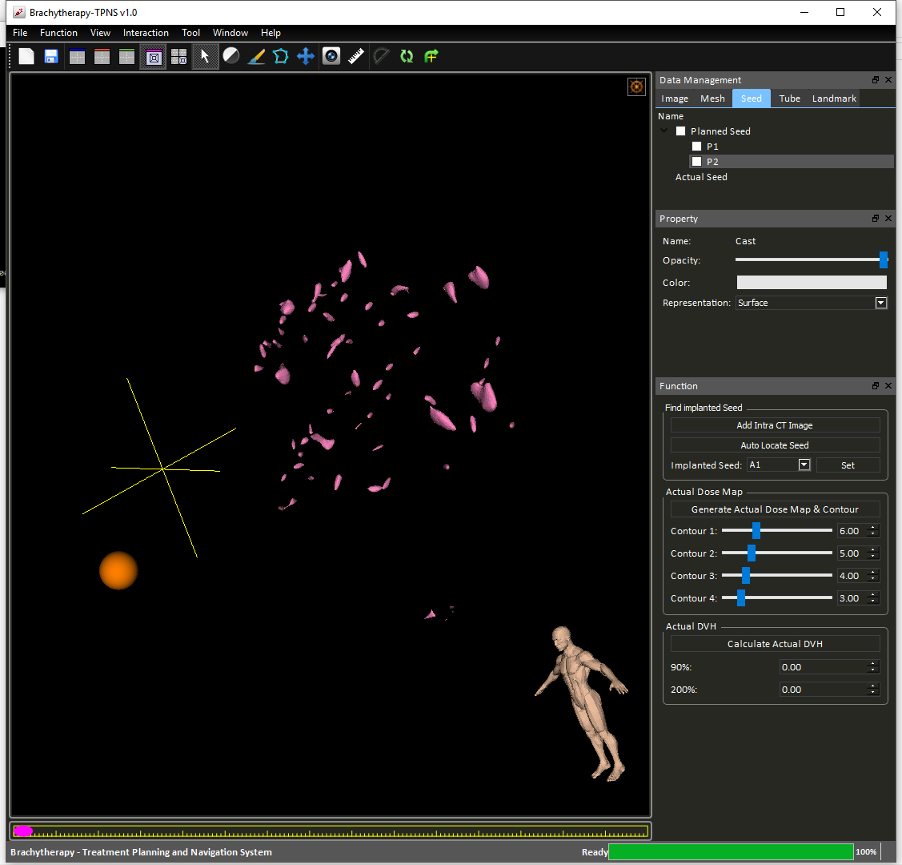

Figure Seed 3D mesh

Then press “Auto Locate Seed” button to approximate seeds’ locations and orientations (Figure 32).

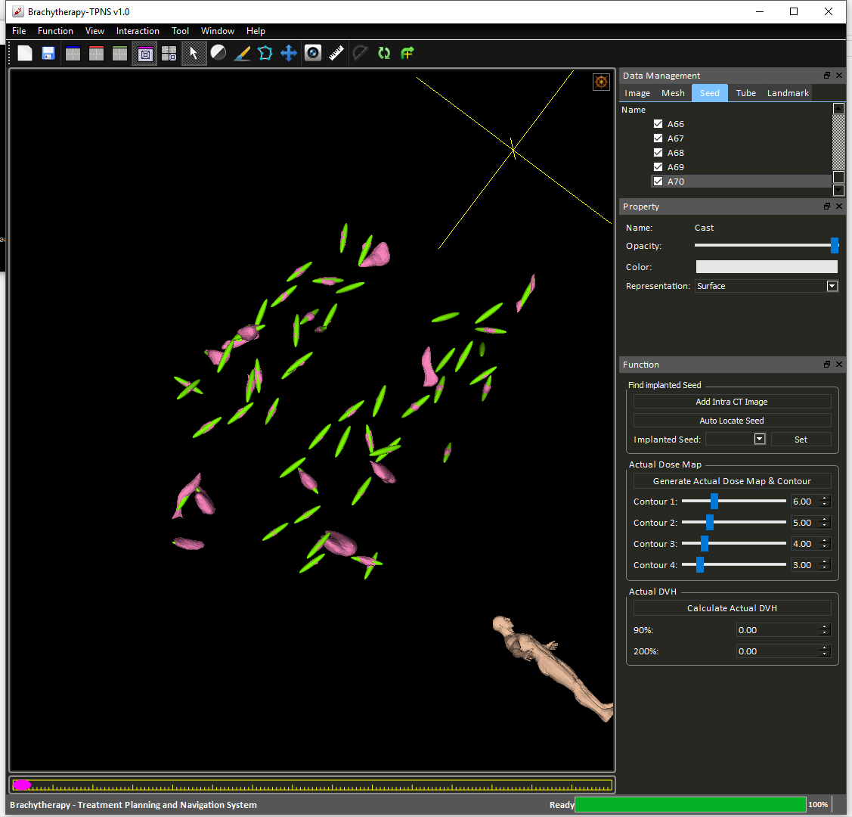

Figure Auto locate Seeds

However, the located seeds can be adjusted by switch to “Seed Adjusting” mode (Figure 33) through clicking the button at the upper right corner of the 3D view port.

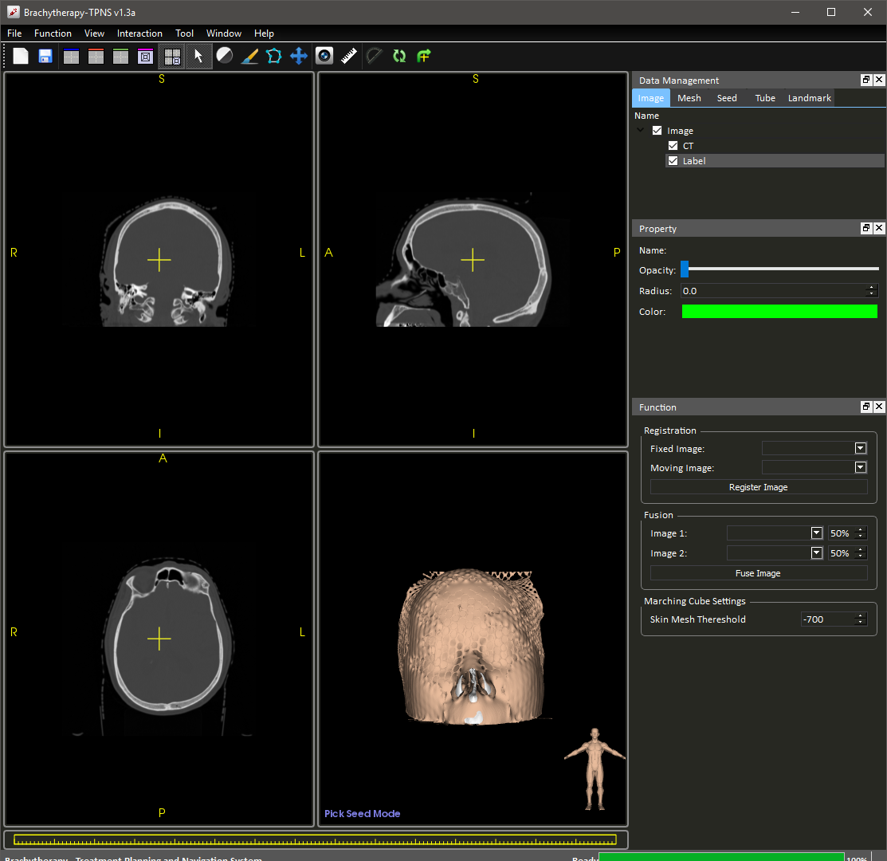

Figure Seed Adjusting mode

In this mode, you can interact with seeds in 3D view port. Hover on the target seed and see it changes color:

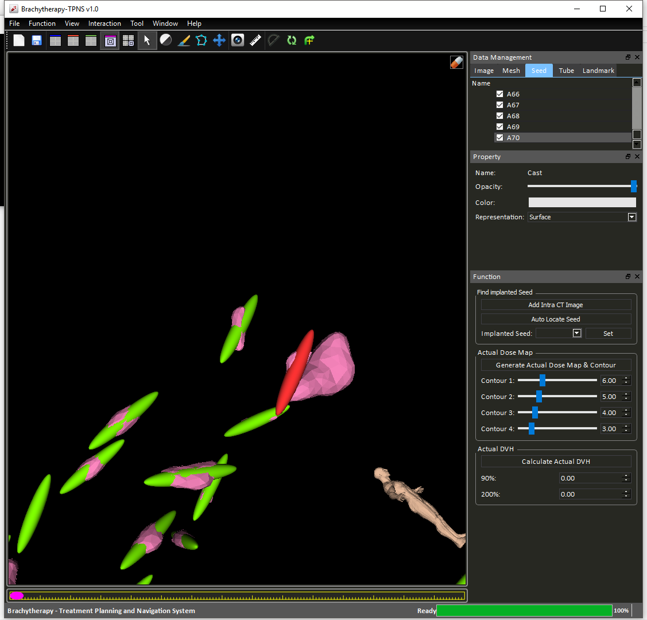

Figure Selecting Seed

The red seeds shows that it is selected. Users can then perform one of the followings actions:

|  |  |
| --- | --- |
| **Actions** | **Functions** |
| Left | Rotate the seed. |
| Crtl + Left | Rotate the seed about the view axis. |
| Shift + Left | Move seed in the plane of display. |
| Middle | Same as Shift + Left. |
| Ctrl + Middle | Move seed in or out of the monitor. |
| Delete | Remove seed from list |
| n | Add new seed at the anchor position (yellow cross) |

## Known Issues

Some cast configuration require further mesh repair before 3D printing.

## Credits

**Prof. Wang, De Feng**

*Assistant Professor, Dept. Image and Interventional Radiology,*

*The Chinese University of Hong Kong*

**Mr. Lok, Ka Hei**

*Mphil. Student, Dept. Image and Interventional Radiology,*

*The Chinese University of Hong Kong*

**Mr. Ko, Jacky**

*Mphil. Student, Dept. Image and Interventional Radiology,*

*The Chinese University of Hong Kong*

**Mr. Wong, Matthew Lun**

*Junior Research Assistant, Dept. Image and Interventional Radiology,*

*The Chinese University of Hong Kong*